Creative Costuming Selections: Recital 2026
Dance families please provide the below items for your dancer’s routines.
All costumes selections must be approved by teachers during our
Creative Costume Approval Week – May 4-7.

Miss Aileen Classes
Class: Lyrical 2
Piece Title: Deeper
Look Description:
- Pale pink flowy pant. (Simple clean look, no patterns)
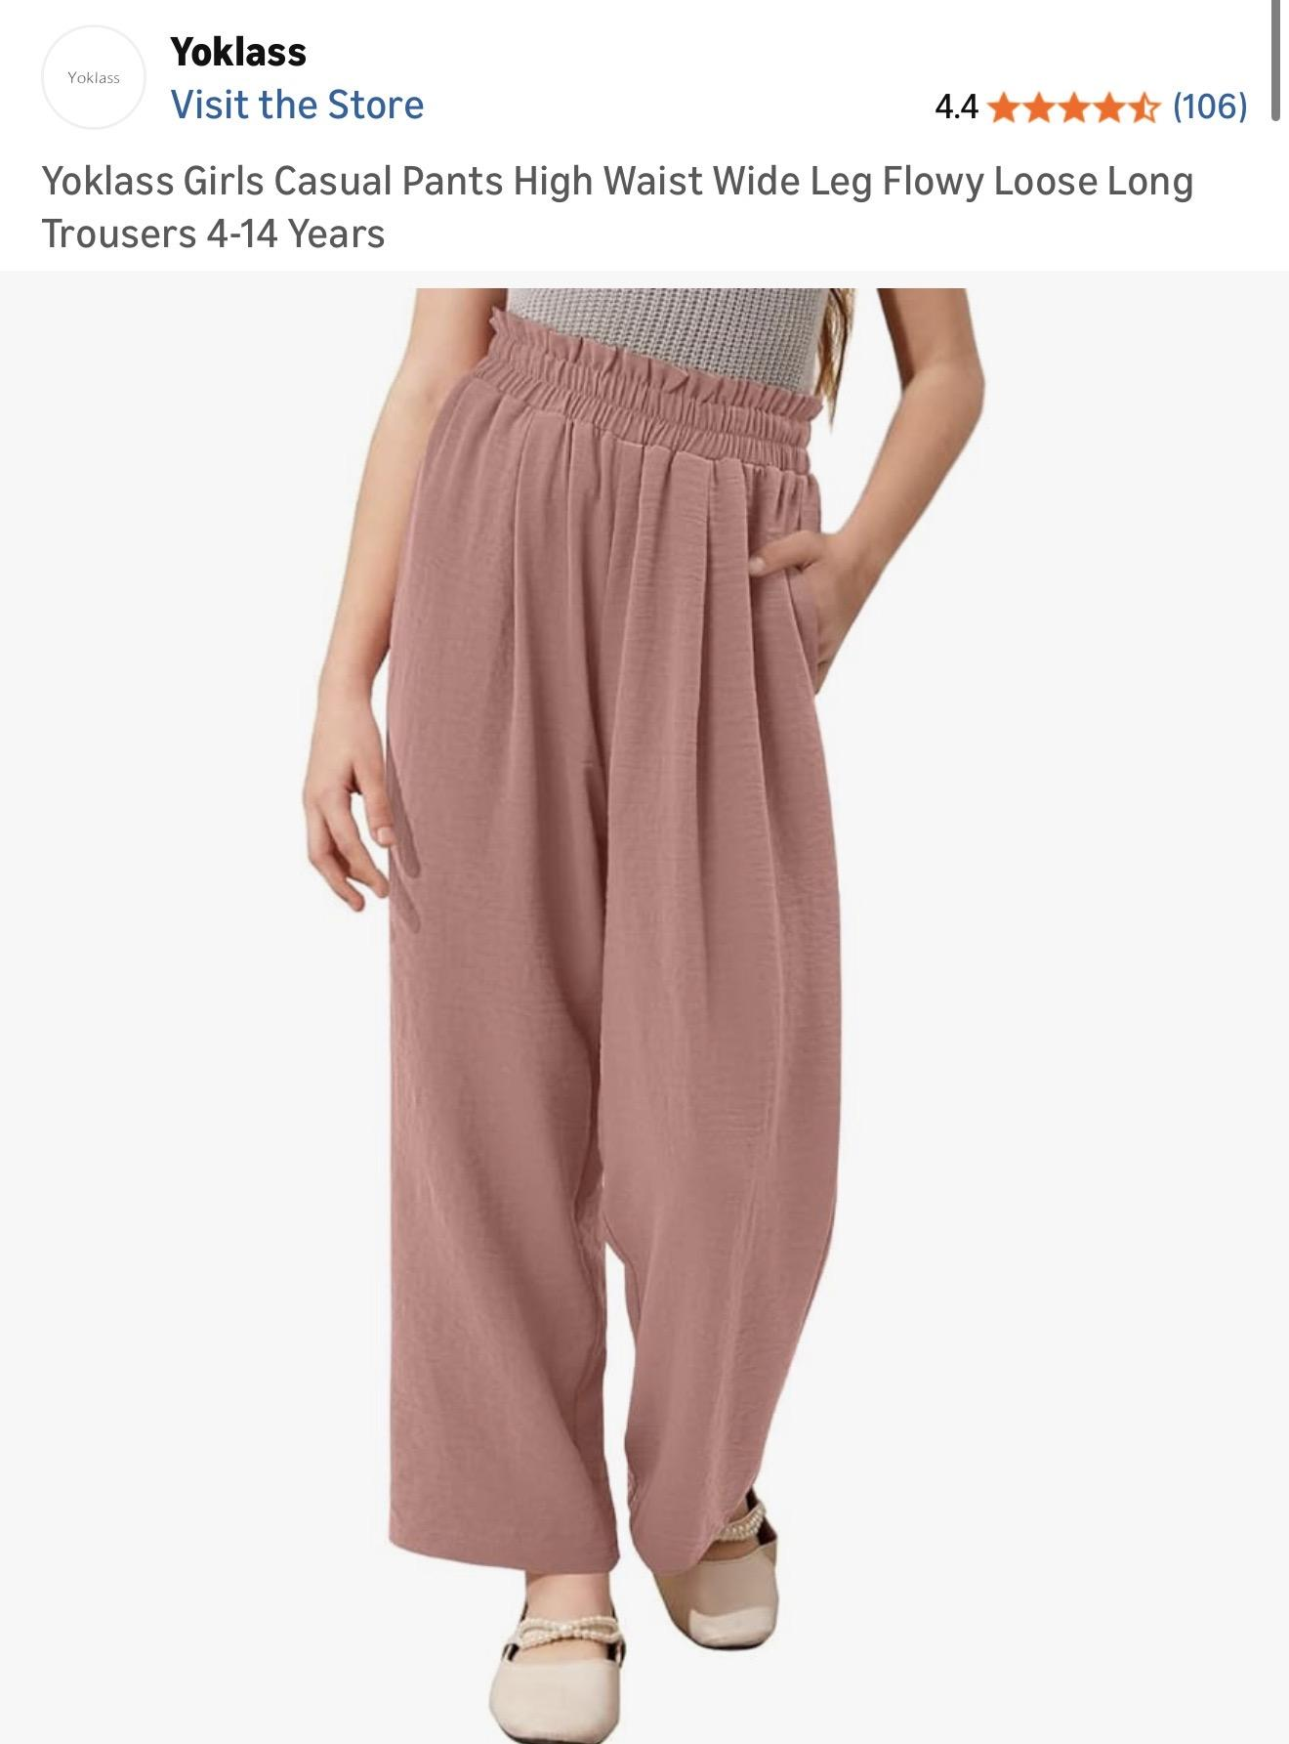
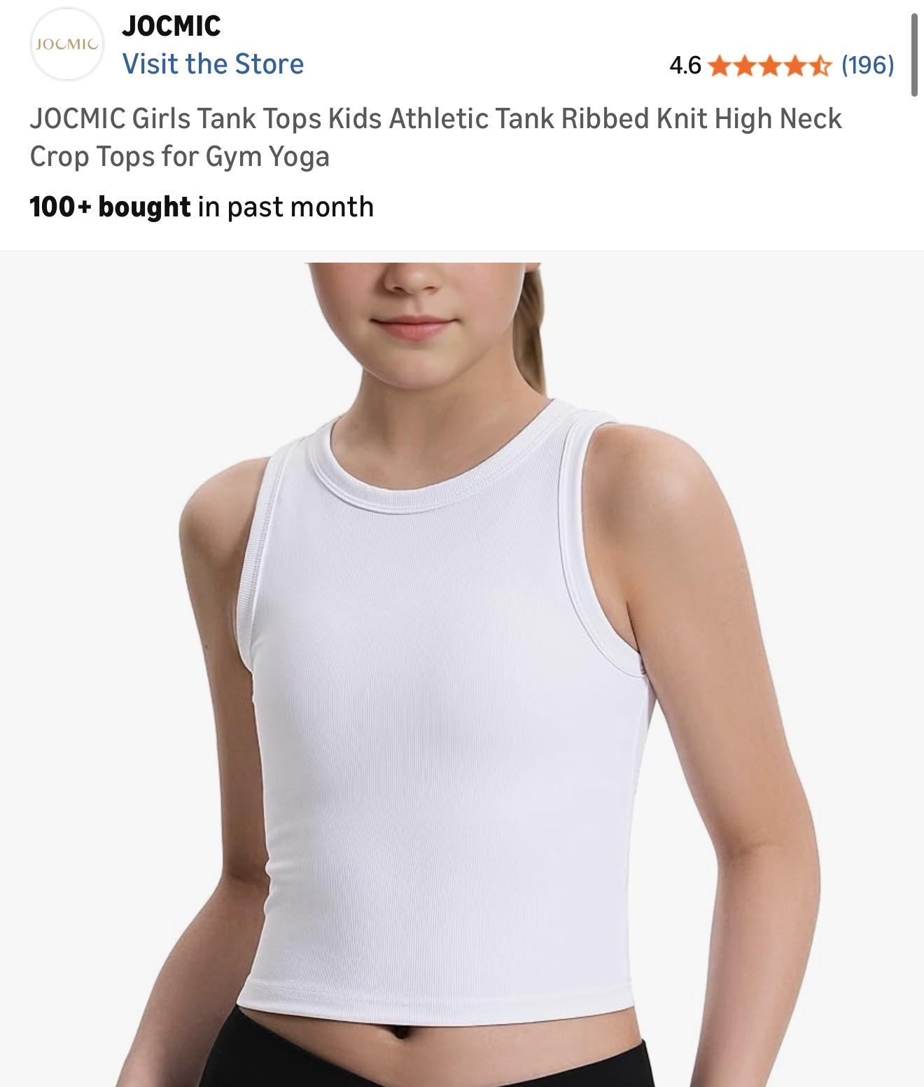
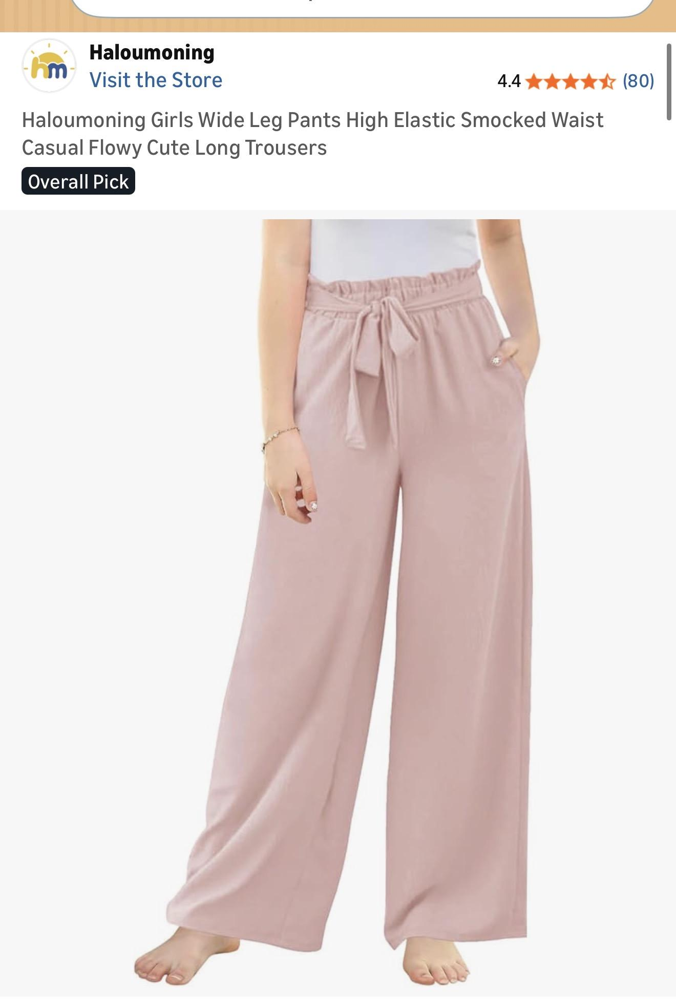
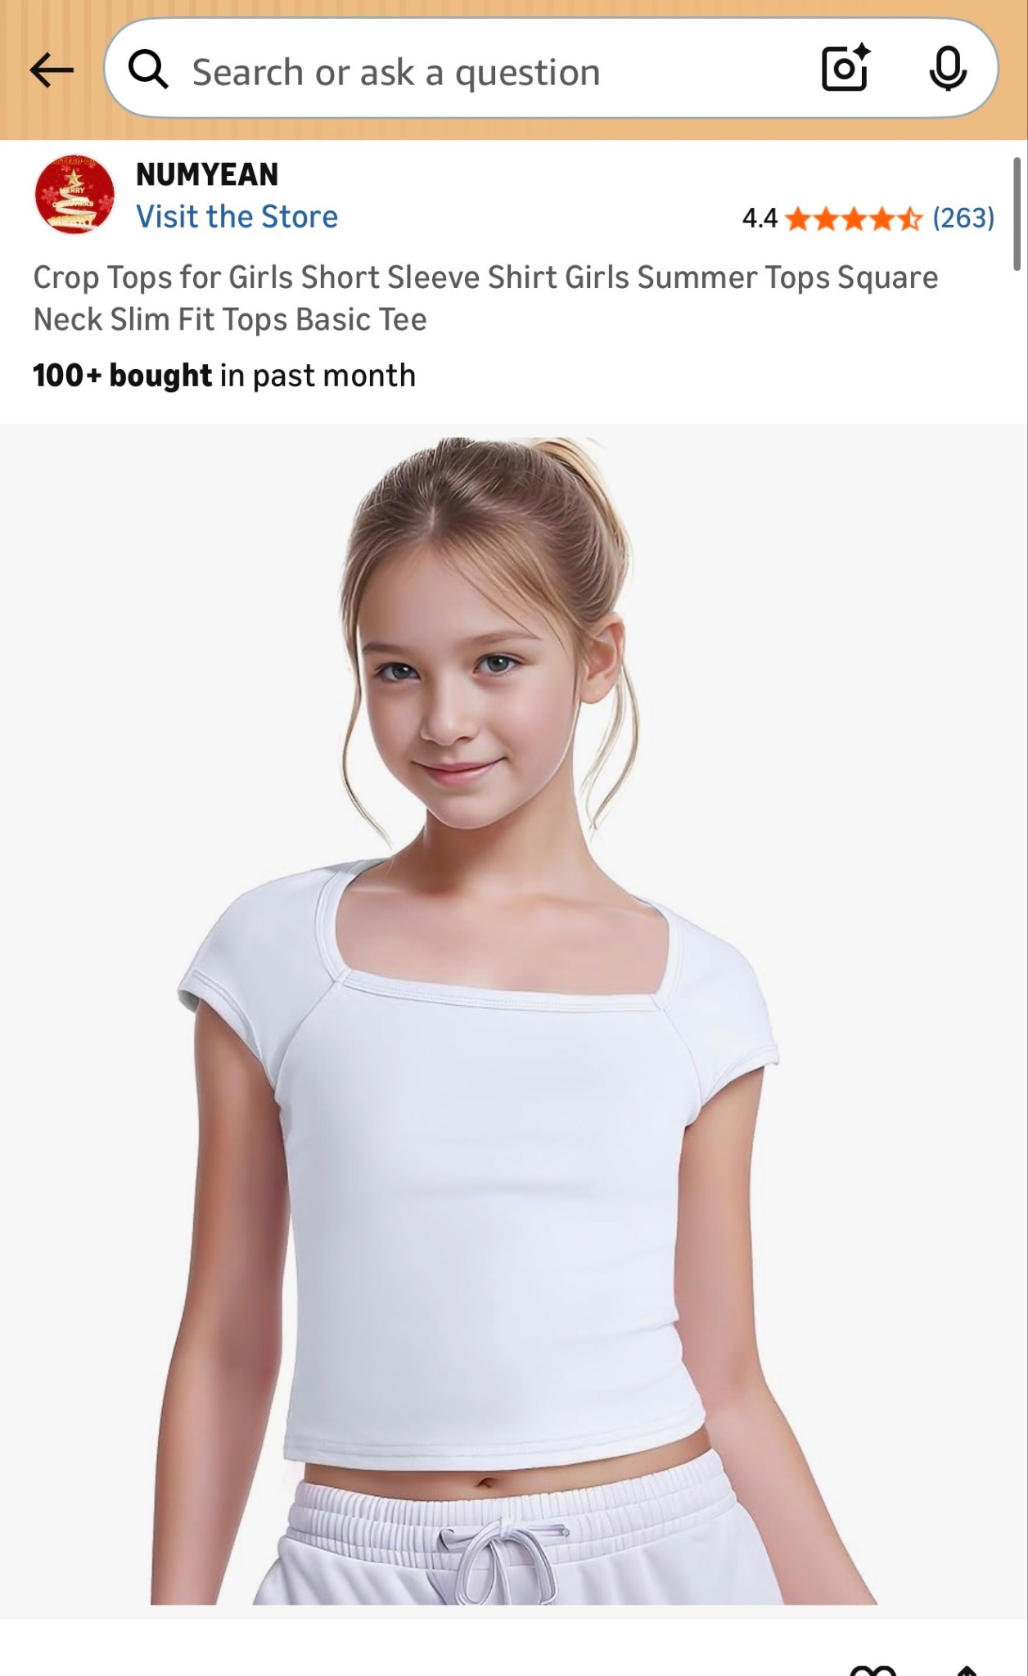
- White fitted tank top (no patterns or sparkles)

Class: Cont/Jazz 2/3
Piece Title: Set Sail
Look Description:
- Navy Blue flowy dress (no sequins or sparkles)
- Navy blue dance short
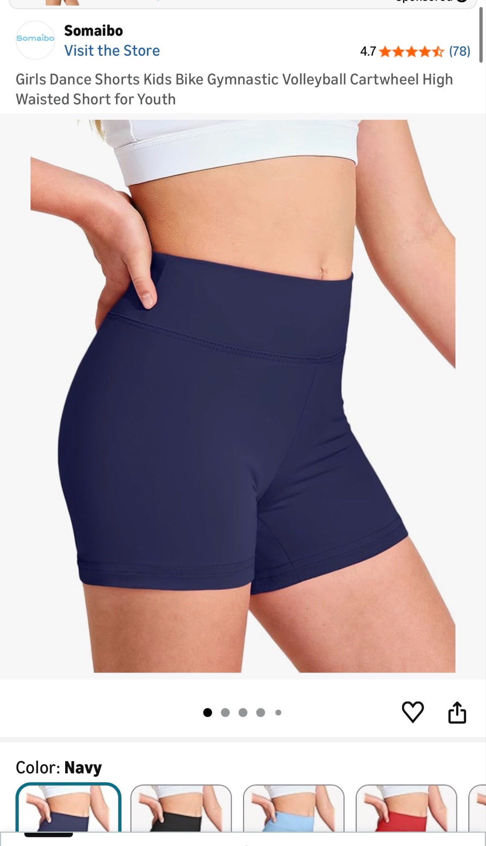
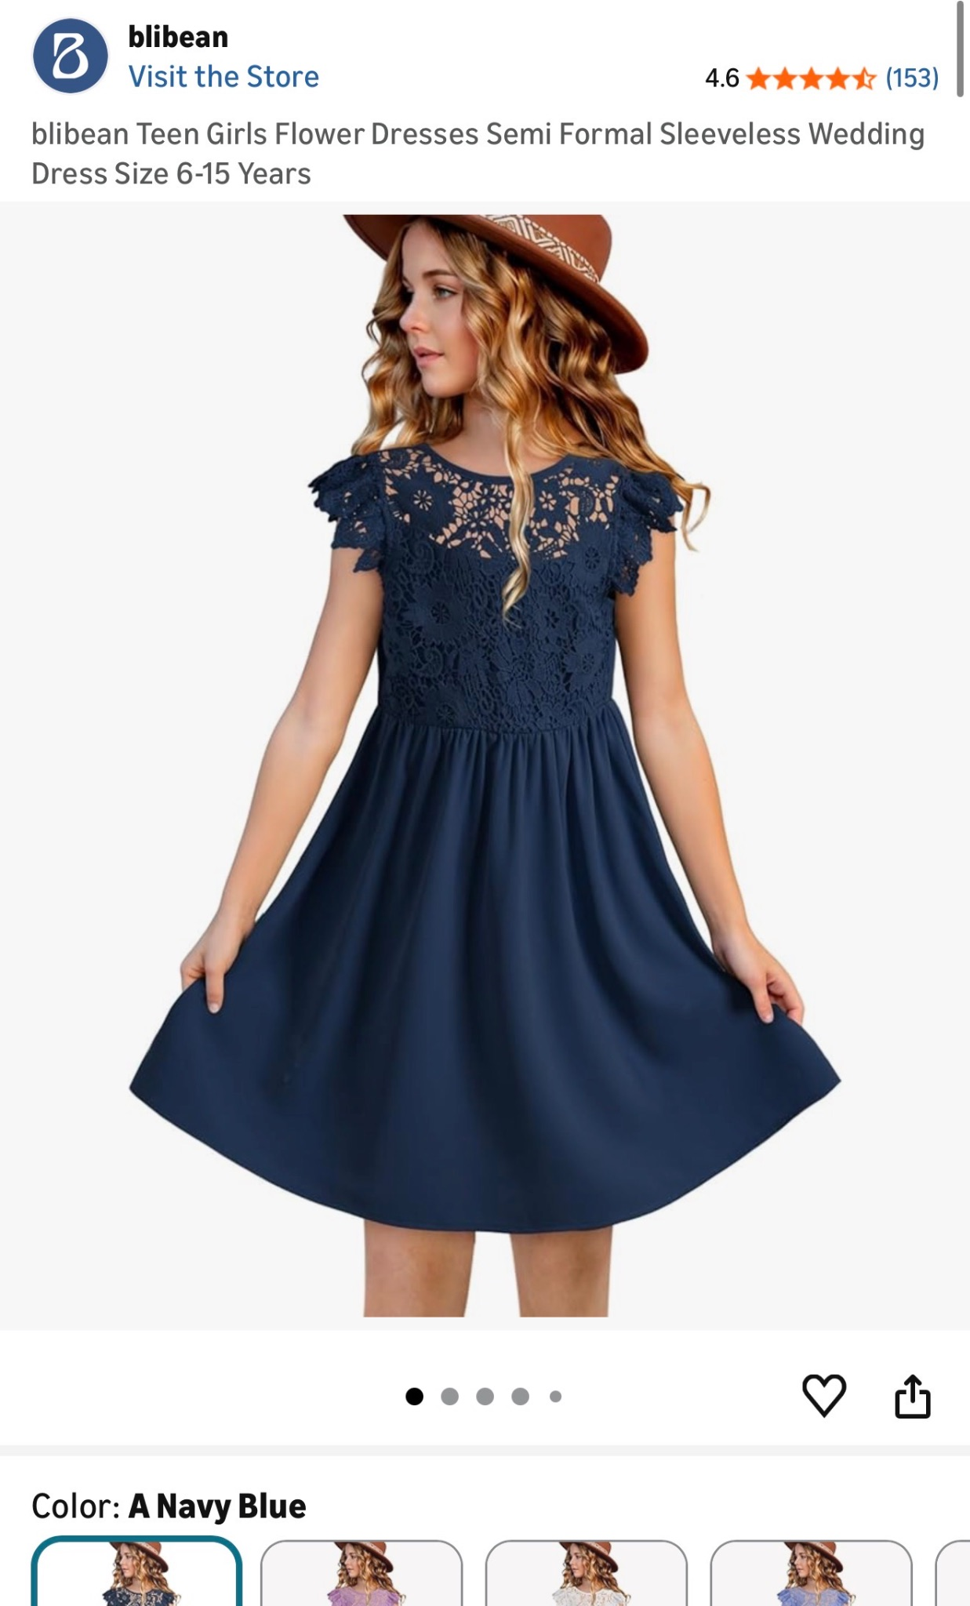
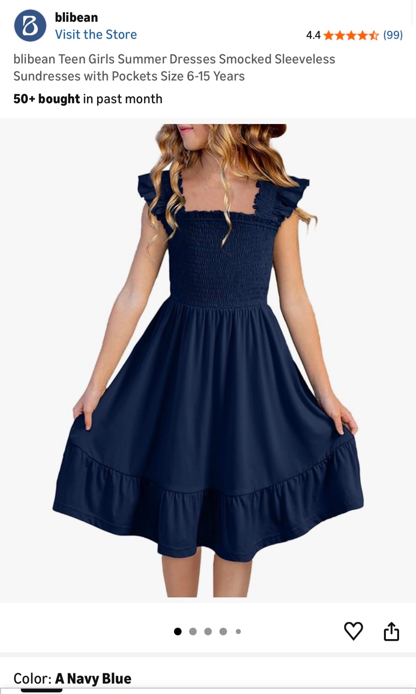
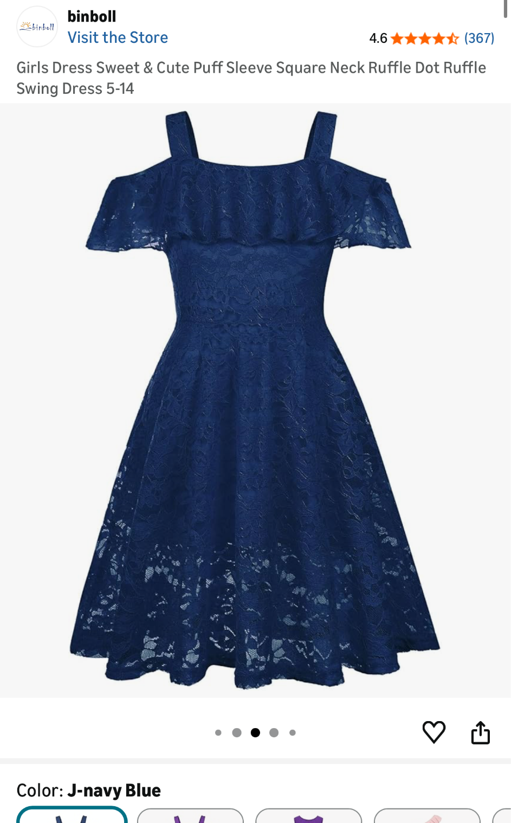

Miss AJ Classes
Class: Tap 6/7
Piece Title:
Look Description: Gap commercial. Blue Denim and white. Wide leg, barrel jeans, and jorts all acceptable. Shirt can be any silhouette. Jean jackets ok. Bandanas, belts, and other accessories ok so long as you can dance comfortably.
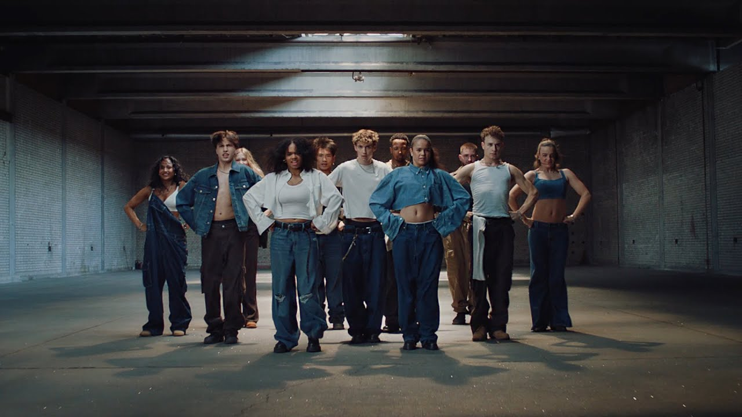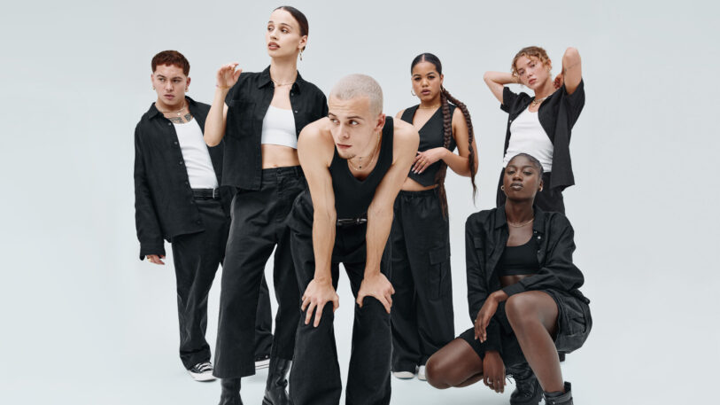

Class: Tap 4/5
Piece Title: The Typewriter
Look Description: Black and White Business Casual- no jeans. Can be pants, a skirt, or dress. Use at least one pattern: stripes or pin stripes, polka dots, houndstooth, chevron, checkerboard, etc. are all ok.

Outfit combination: bottoms + top + 1 black or white “retro” accessory: fingerless gloves, fascinator, eyeglasses/’readers’ on a chain, pocket square, fedora, etc
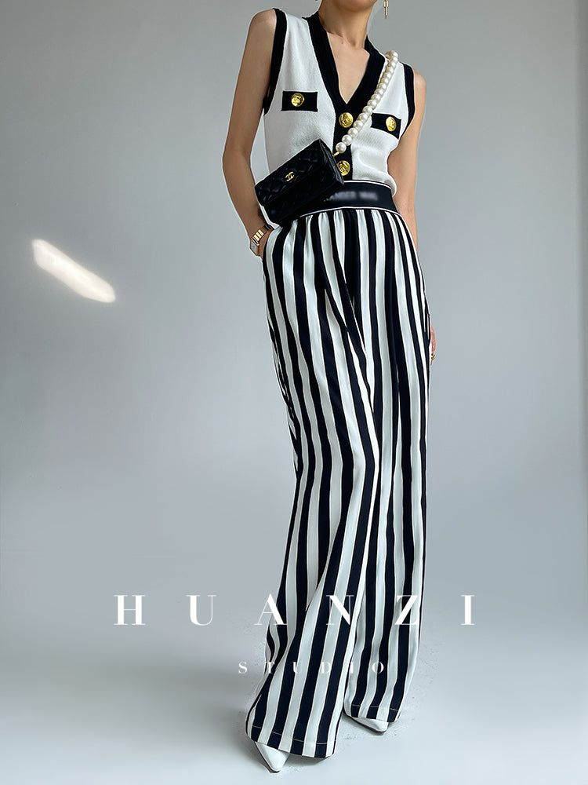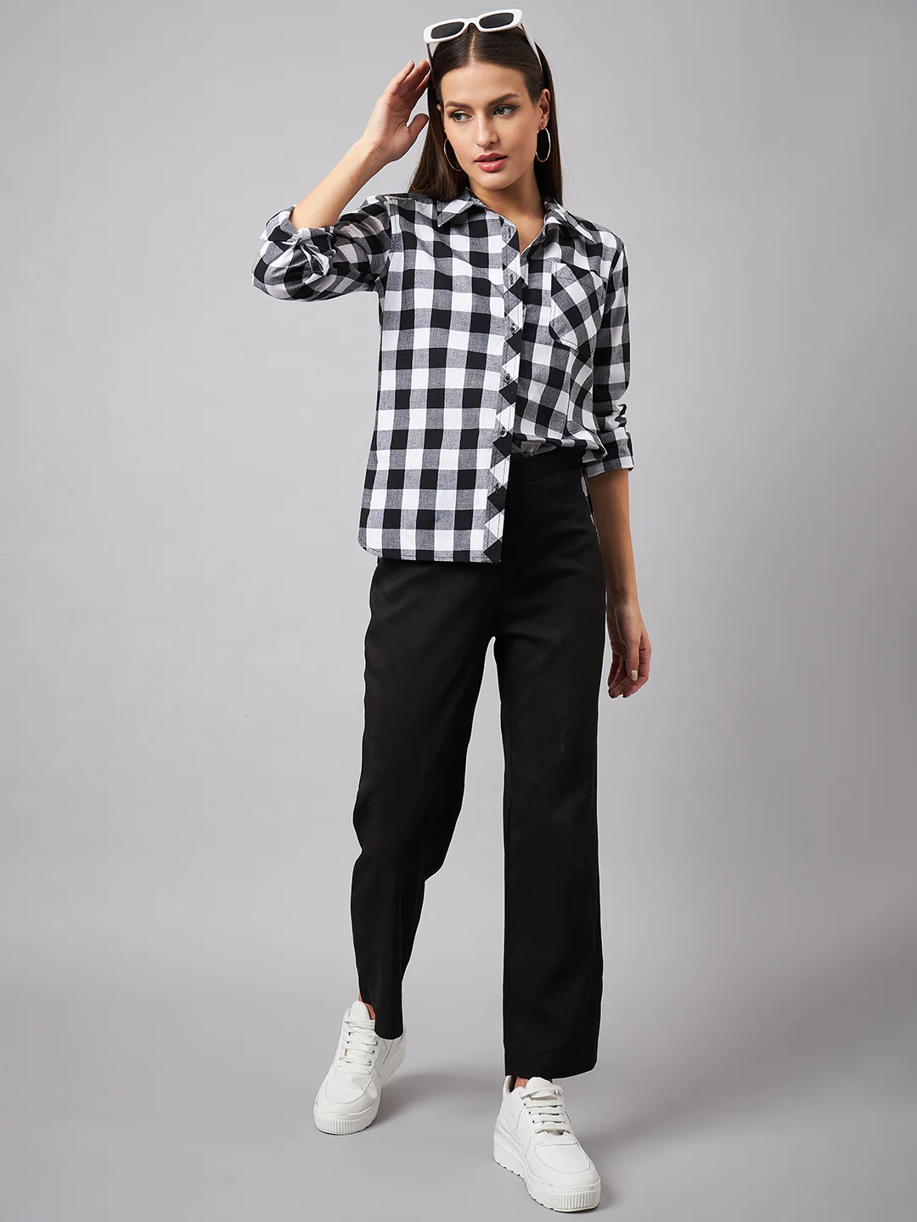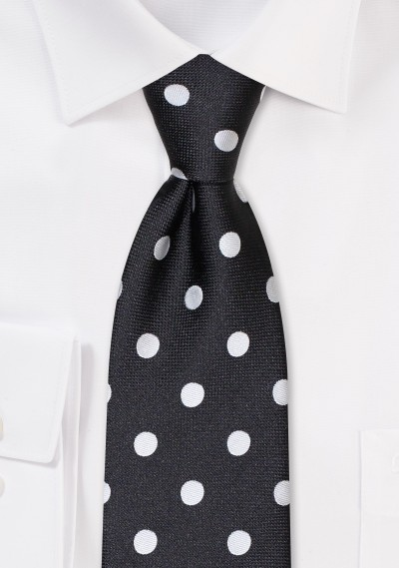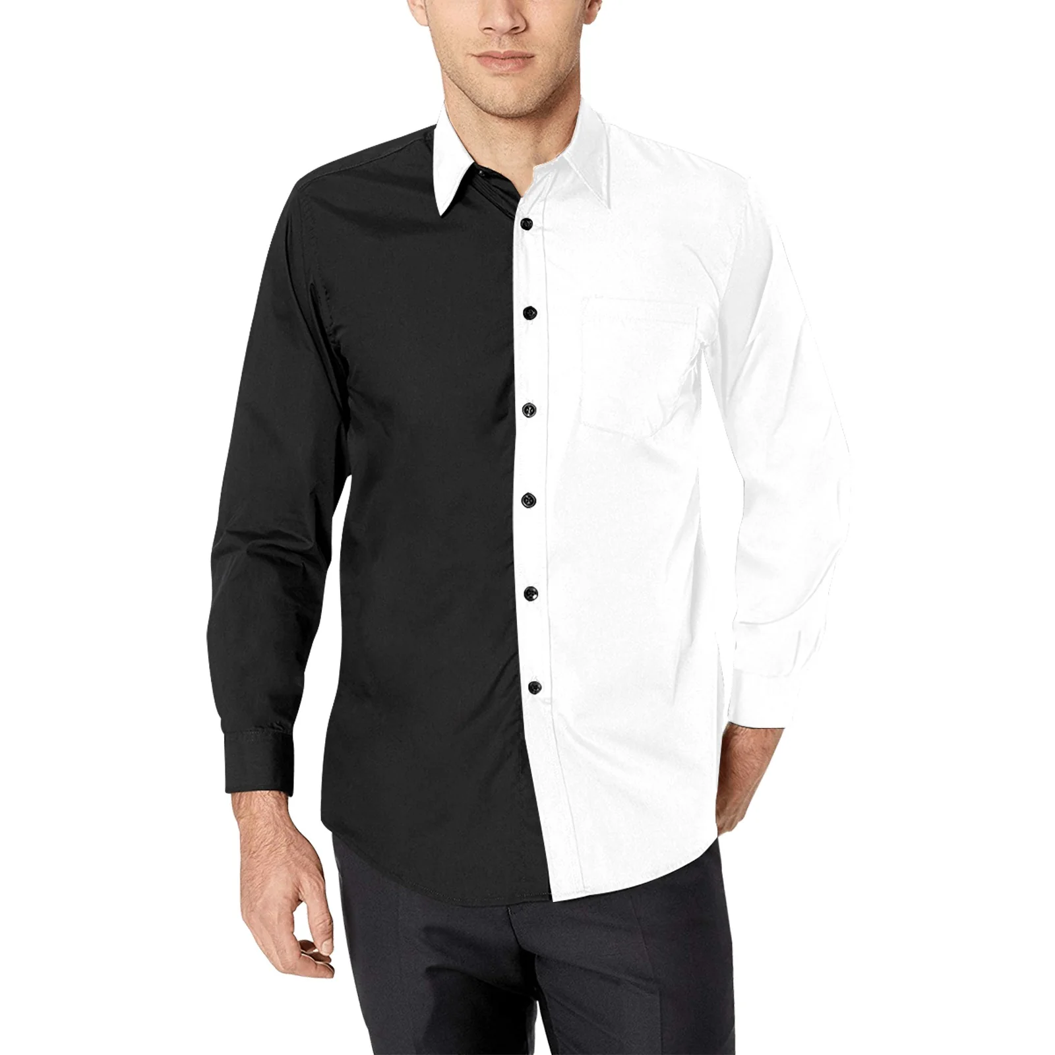

Miss Emma Classes
Class: Contemporary 4
Piece Title: Let Me Follow
Look Description: Tank top, flowy overshirt, and pants in blues and greens
- Stick to rich, ocean blues, teals, and blueish-greens for all pieces (no patterns/prints)
  - Each piece should be a different shade/color (example: teal top with deep blue pants and a sea green overshirt)
- 3 pieces: 1) A fitted tank top 2) Flowy pants 3) A lighter, flowy material long-sleeve overshirt to be worn open and over the tank top (example: a button up shirt made of a fabric like gauze, satin, etc. - something with movement)
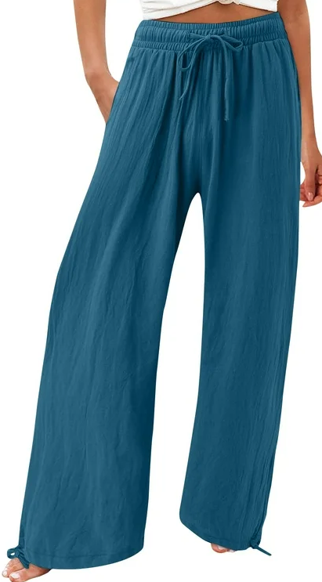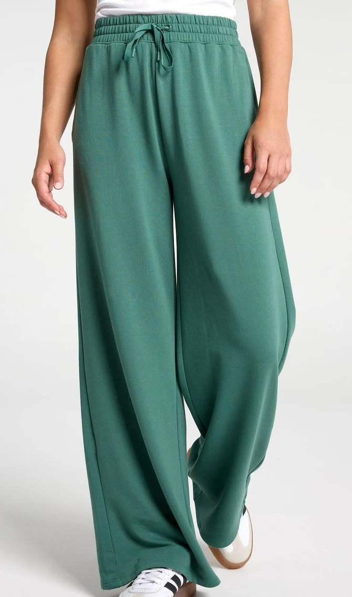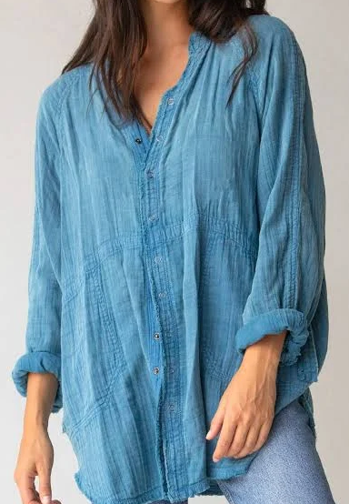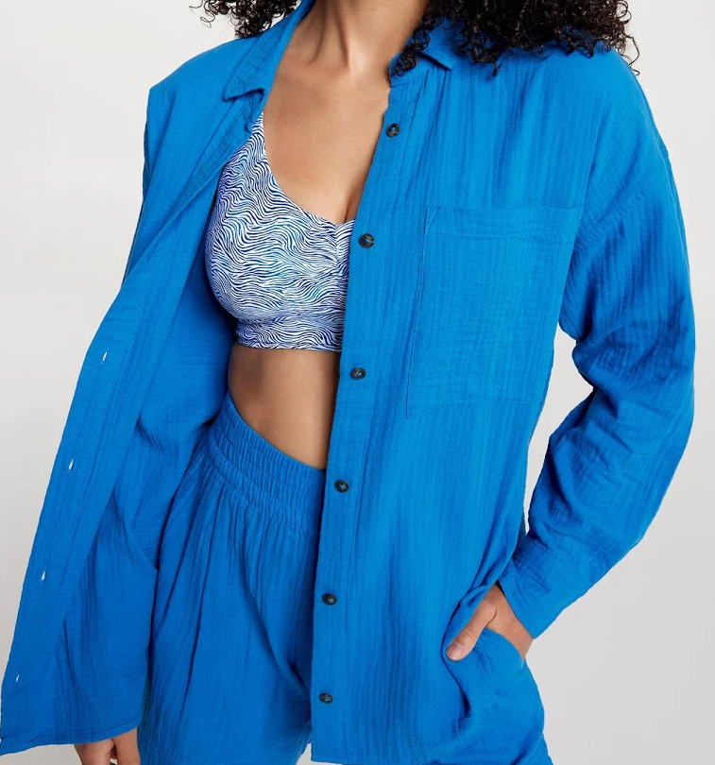

Class: Jazz 6
Piece Title: Chic
Look Description: All black with mesh polka dot gloves
- Sleeveless black top
- Black pants (no jeans, please)
- Black mesh polka dot, opera-length gloves (see link below):
  - https://a.co/d/0iJV8qUt
- Additional black accessories (pick at least one): sunglasses, scarves, small hats (ex. beret or fascinator)
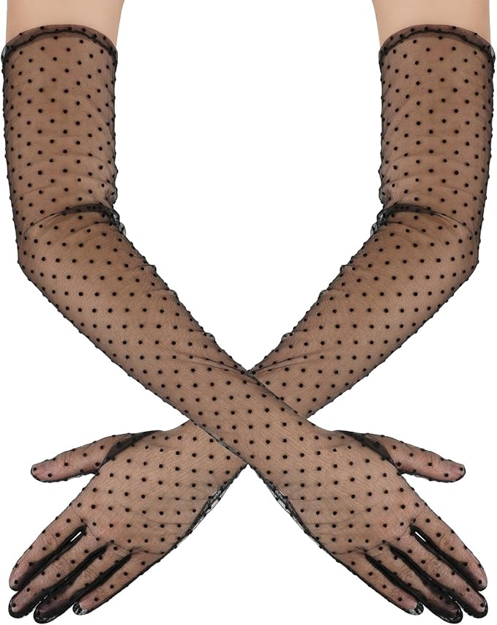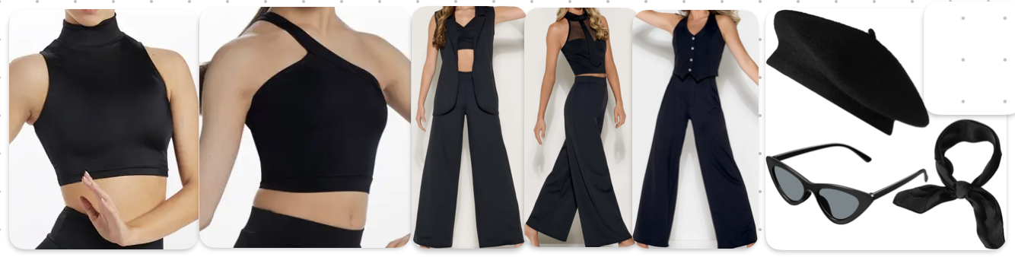

Miss Fatima’s Classes
Class: Contemporary 5
Piece Title: You Know The Feeling
Look Description: Any loose slack pants and top in the below beige palette. Shades like “Cream”, “Beige”, “Khaki”. No lace, patterns, or harsh textures. Doesn’t need to be monochrome, mix/match shades between top and pants preferred.
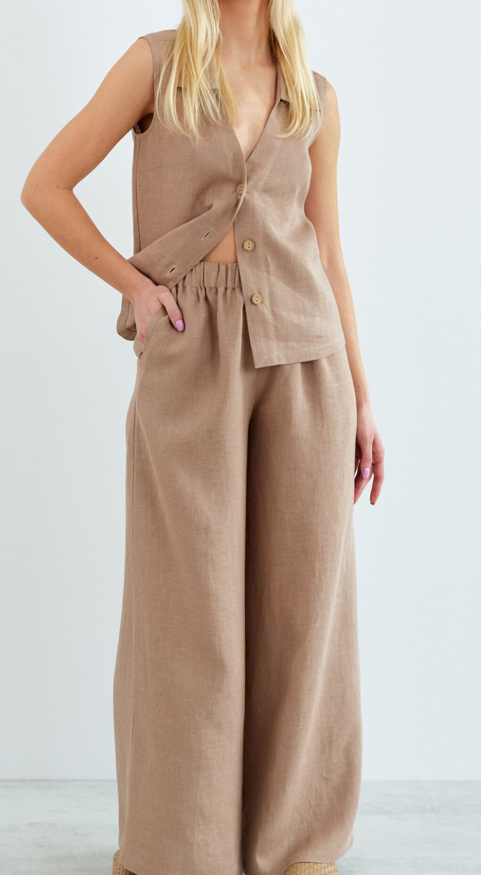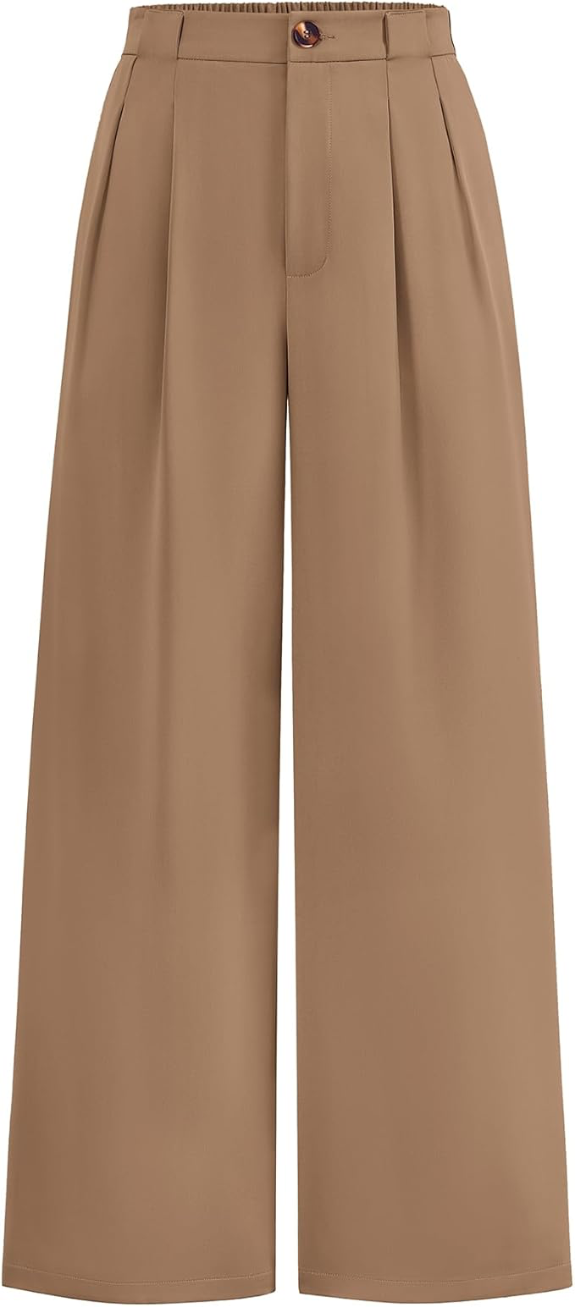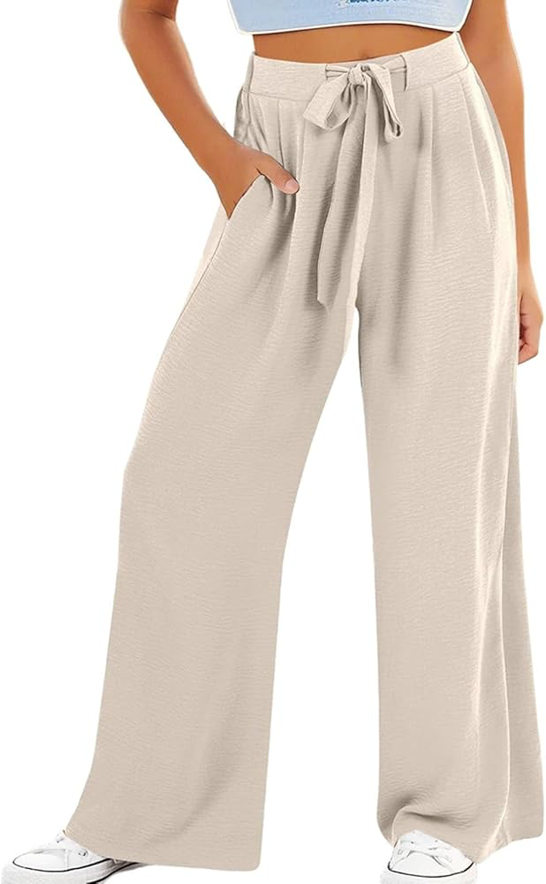
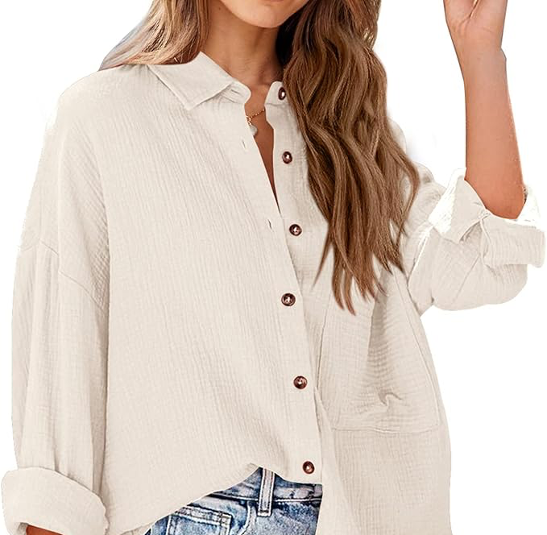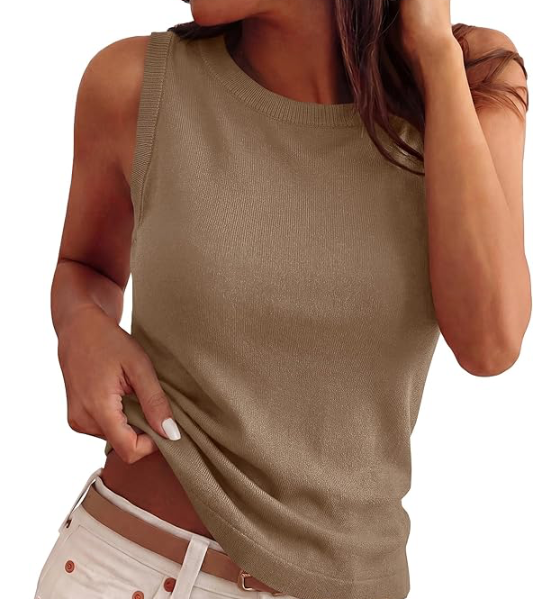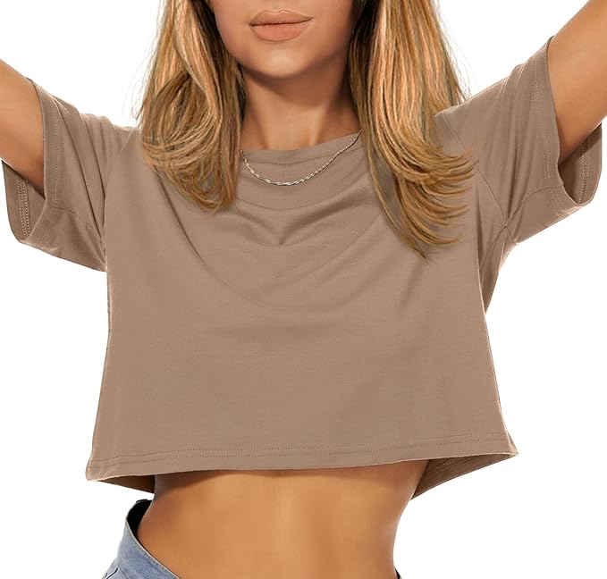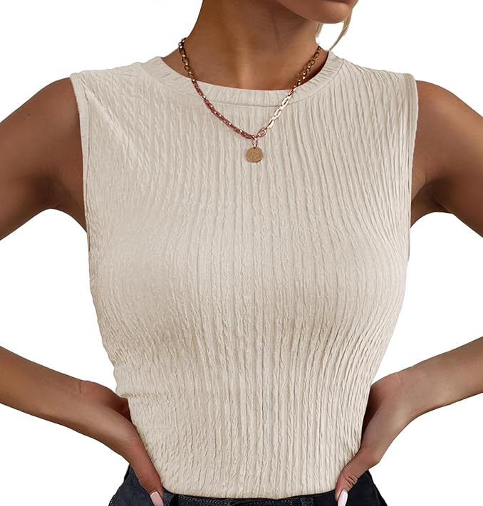

Miss Gaby’s Classes
Class: Jazz 3
Piece Title: That Walk
Look Description: Black strappy leotard and purple skirt

Purple Skirt on Amazon!

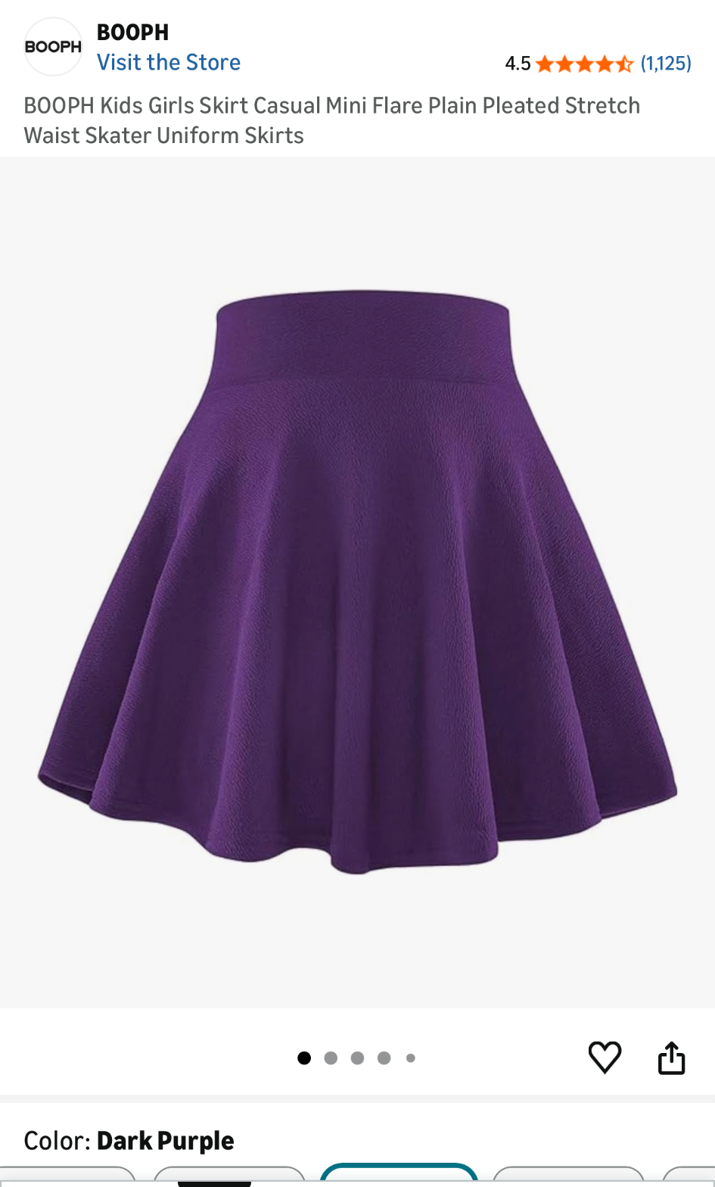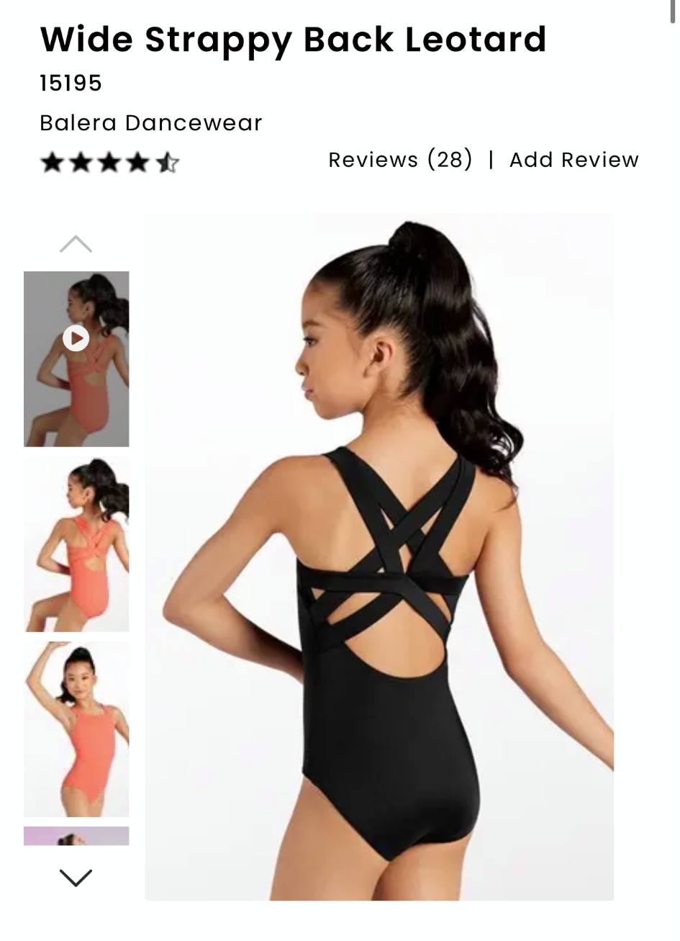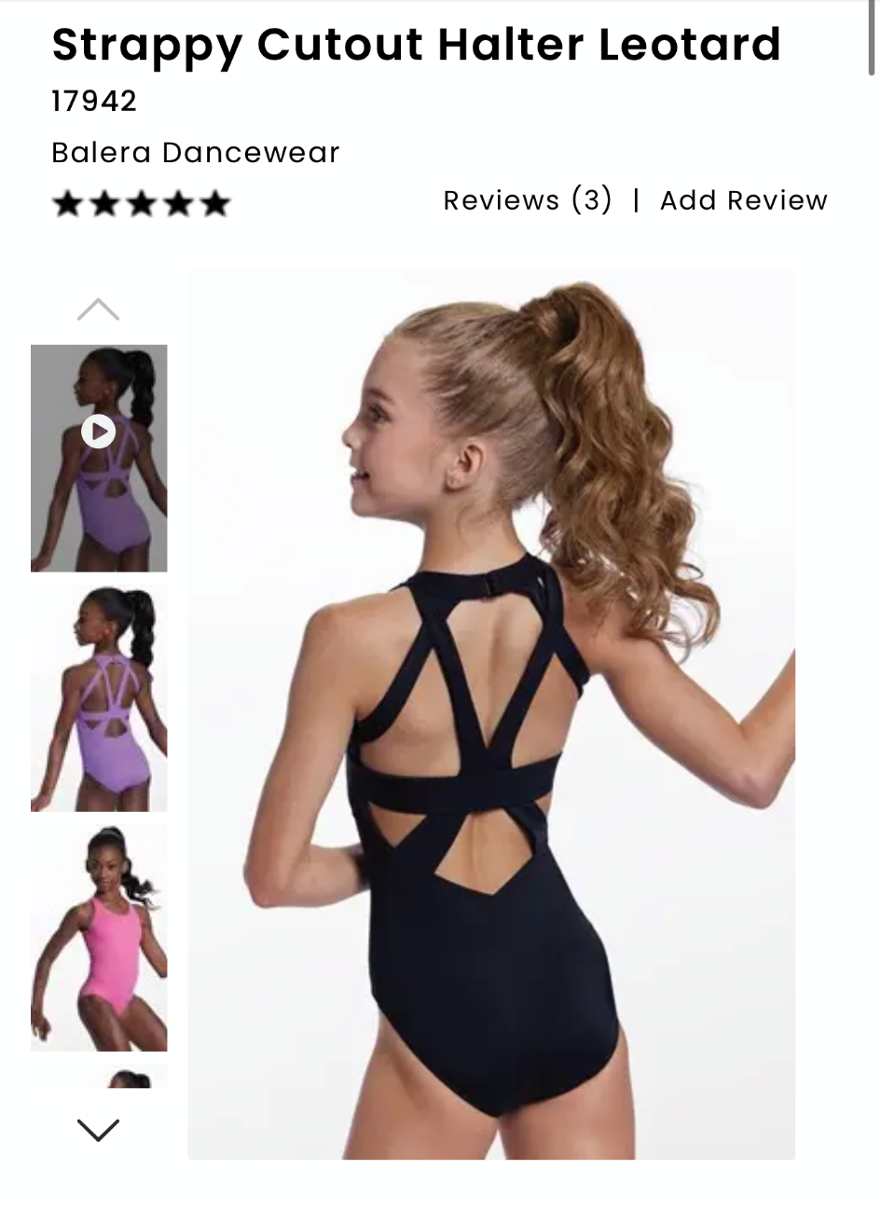

Kaylan’s Classes
Class: Hip-Hop 2
Piece Title: Breakin Dishes
Look Description: Black Cargo Pants, Black Shoes, Cobalt Blue Top (short or long sleeve, can have designs or graphics ( black or white lettering ) on it but please bring it in for me to see first)

Shirt OPTIONS:
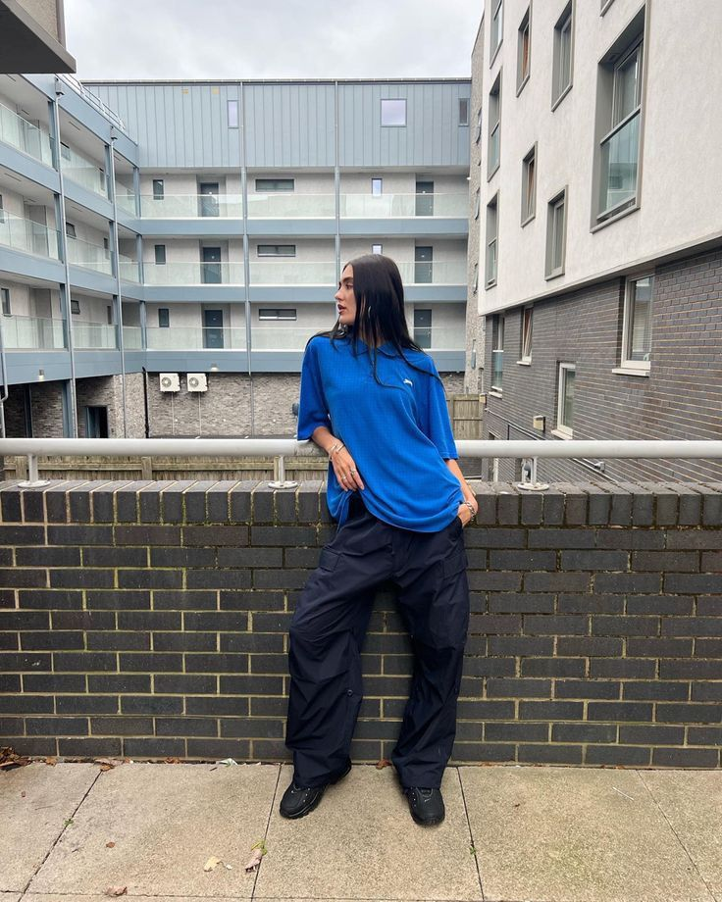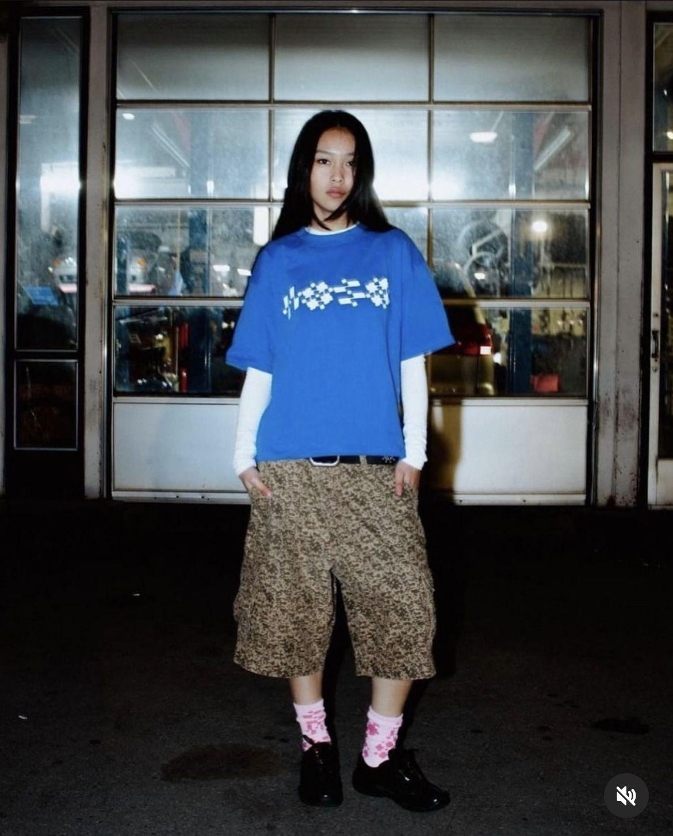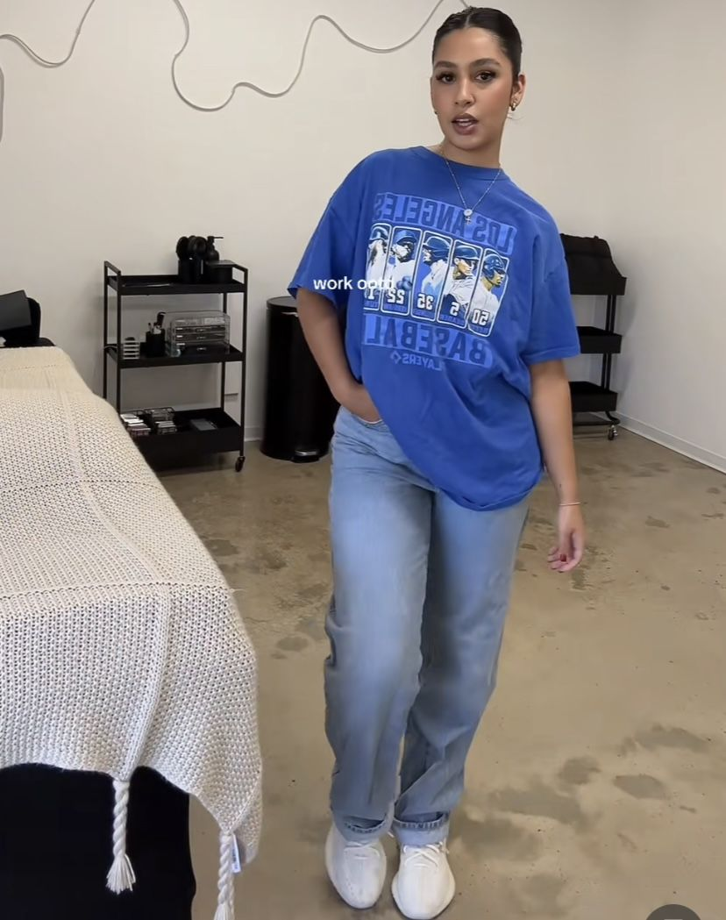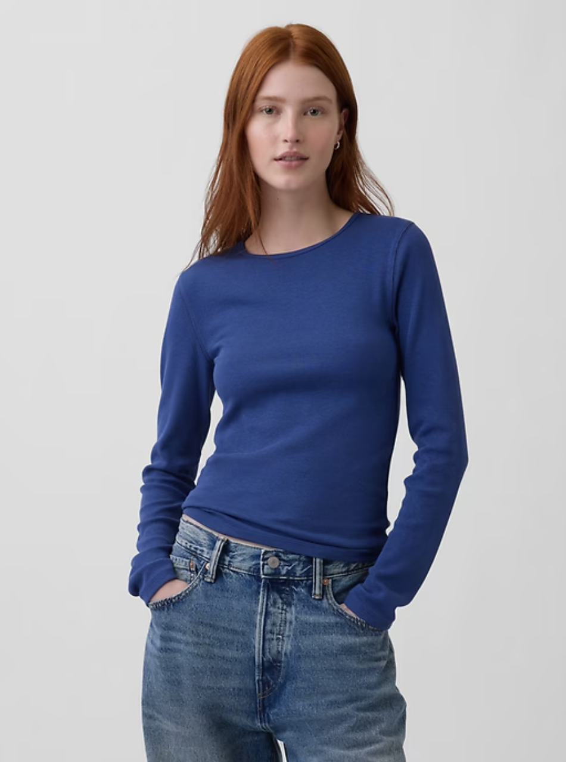
Cargo pant OPTIONS:
Amazon 1 PANTS
Amazon 2 PANTS

Miss Krista’s and Nicole’s Classes
Class: Jazz 2
Piece Title: Microphone
Look Description: Miami inspired bright happy warm colors fitted top and more flowy white pant (not jeans)
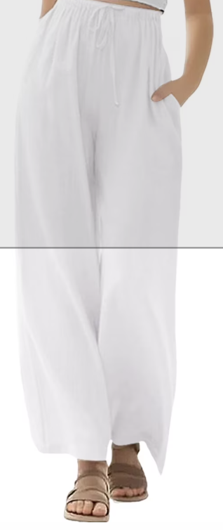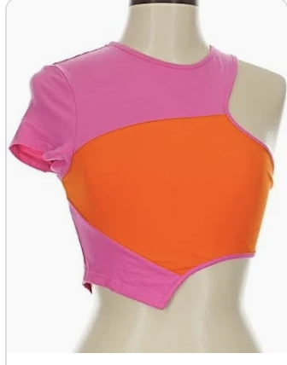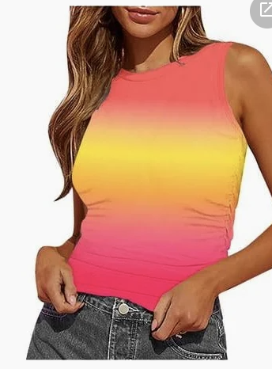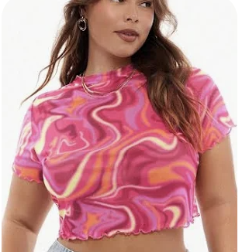

Class: Contemporary 3
Piece Title: In Dreams
Look Description: Flowy white dresses right above the knee, short sleeve or tank top (no lace, mesh, sequins, minimal textures), white bike shorts under
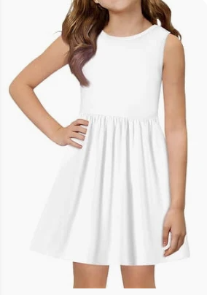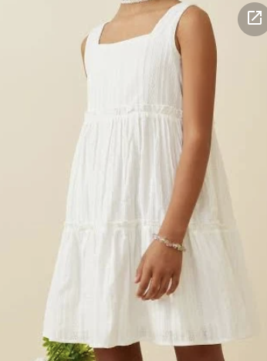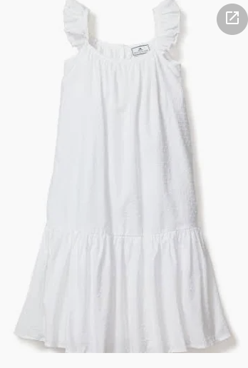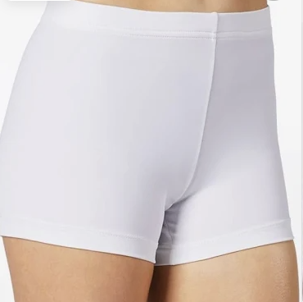

Class: Jazz 4
Piece Title: End Of The Road
Look Description: Black mixed fabric with pops of cheetah
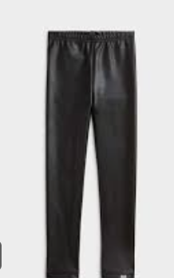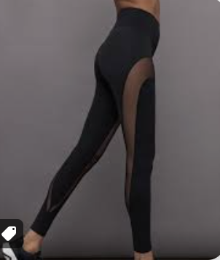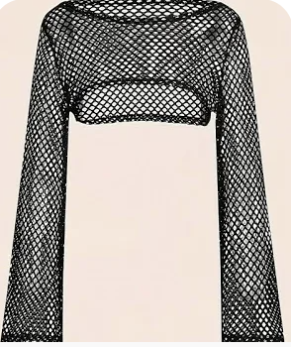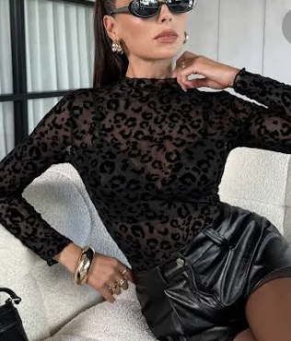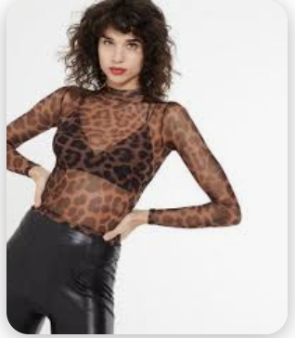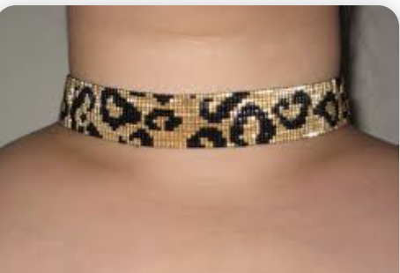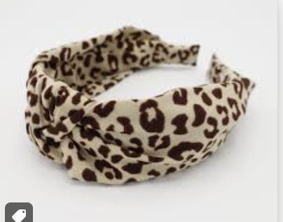

Miss Lucetta’s Classes
Class: Tap 2/3
Piece Title: Little Black Dress
Look Description: “Little Black Dress” w/ Black dance shorts under.

Mr. Neico’s Classes
Class: Hip Hop 4
Piece Title:
Look Description: White shoes & this pink fit https://share.temu.com/VQDrO8wALHC
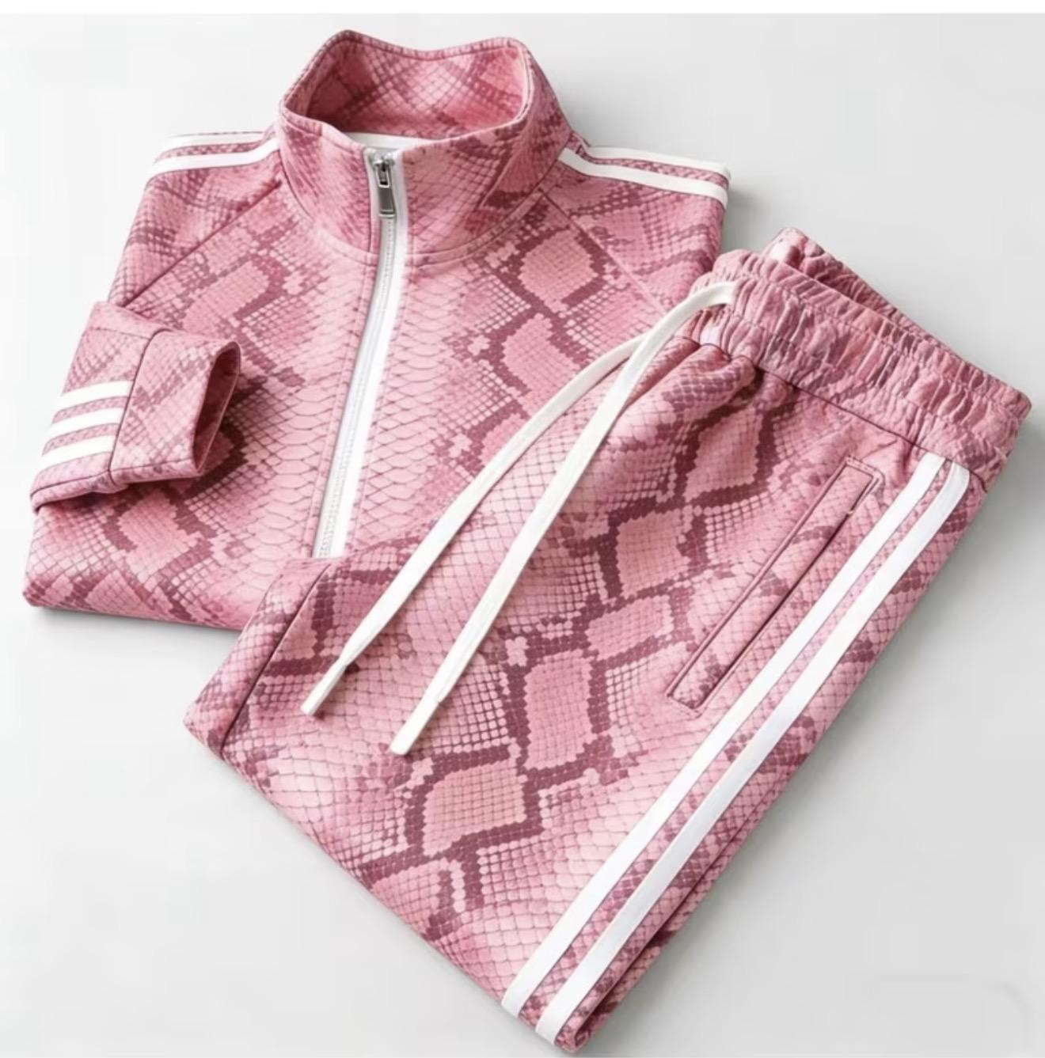

Class: Hip Hop 3
Piece Title:
Look Description: Black shoes, black jersey long sleeve top, with dark grey sweatpants Inspo: https://share.temu.com/lJUV4Bn9VQC
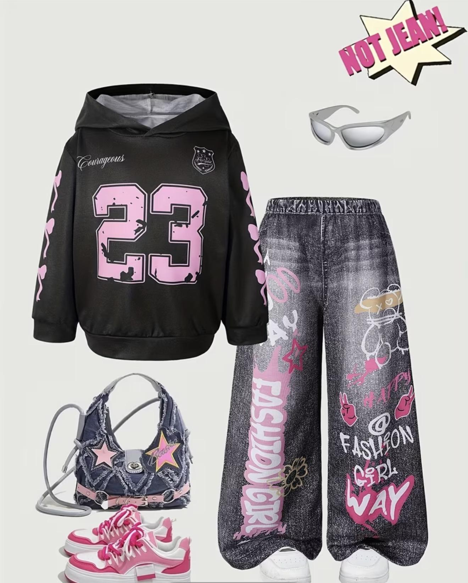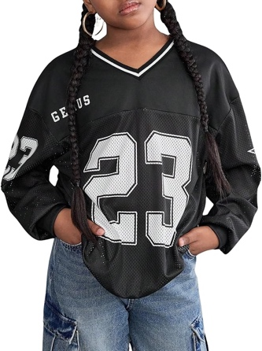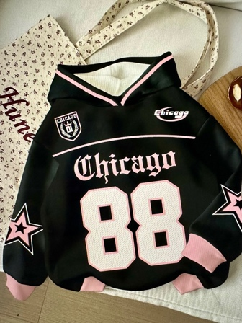

Class: Hip Hop 7
Piece Title:
Look Description: baggy, jean shorts with long sleeve flannel shirt, white tennis shoes
