Creative Costuming Selections
All costumes should be shown to teachers during the week of 5.5-5.8

Miss AJ’s Classes
Class: Tap 2
Piece Title: “Bubble Bath”
Look Description: Tops are cap or short sleeved, with no writing please

Group 1: Baby blue top
KK, Lila, Quinn, Izzy
Group 2: Mint Green
Yeji, Amelia, Lizzie, Audi, Ella
Group 3: Teal top
Sam, Rosemary, Wanda, Adriana

Hairpiece: This headband, white bubble headband
Pants: white flare pants (double-lined or dance pants to prevent sheerness)
Socks: none or no-show

Class: Tap 3/4
Piece Title: “Hats Off”
Look Description: Hat: dancers may choose any hat of their choice. They must be ab
le to remove their hat and return it to their head during the dance. Cowboy hats, bowler, fedora, sun hat, ONE baseball cap, lady’s hat, derby hat, newsboy hat, beret- dancer’s choice!

Top: Casual black top/shirt
Bottoms: medium or dark blue denim jeans
Socks: Black socks reaching to mid calf

Class: Tap 5
Piece Title: “1 + 5 Step”
Look Description: all black. Please include at least 2 different textures and different silhouettes. Think velvet, leather, mesh, ribbed, patterned, etc.

Examples: wide leg pants and fitted top, straight leg pants and top with bell sleeves, skirt, top, and jacket.

Noelle: add a white base layer than can be hidden and revealed
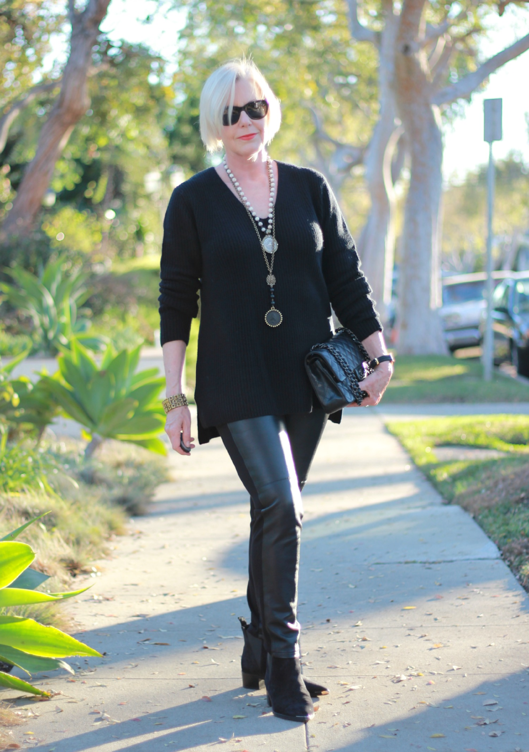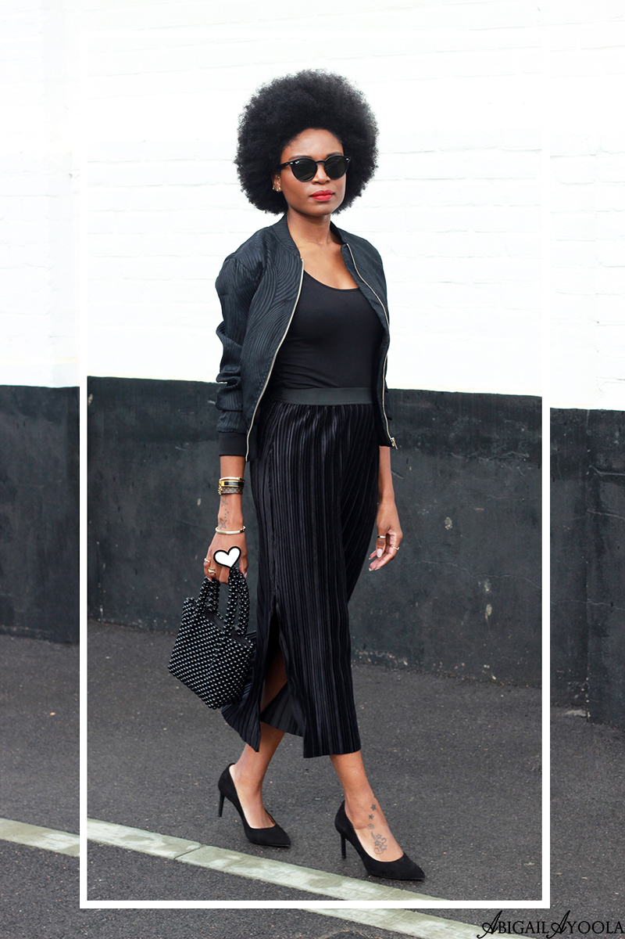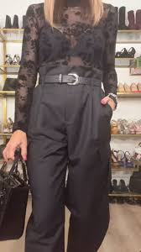

Class: Tap 6
Piece Title: TBA
Look Description: New Year’s Eve attire. Metallics, sequins, bold/rich tones

Miss Amanda’s Classes
Class: Lyrical 2
Piece Title: “The Winner Takes it All”
Look Description:
- Cocktail dress (formal looking)
  - At or above the knee
  - Any sleeve type
  - No patterns but rhinestones, sequins, and different textures are alright
  - Pastel colored (blue, pink, yellow, green and purple)
- White booty shorts for underneath
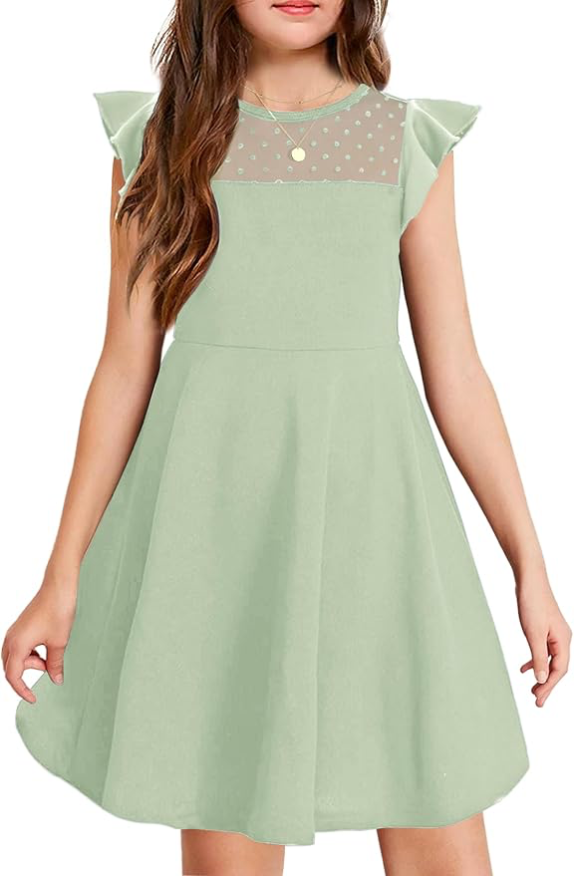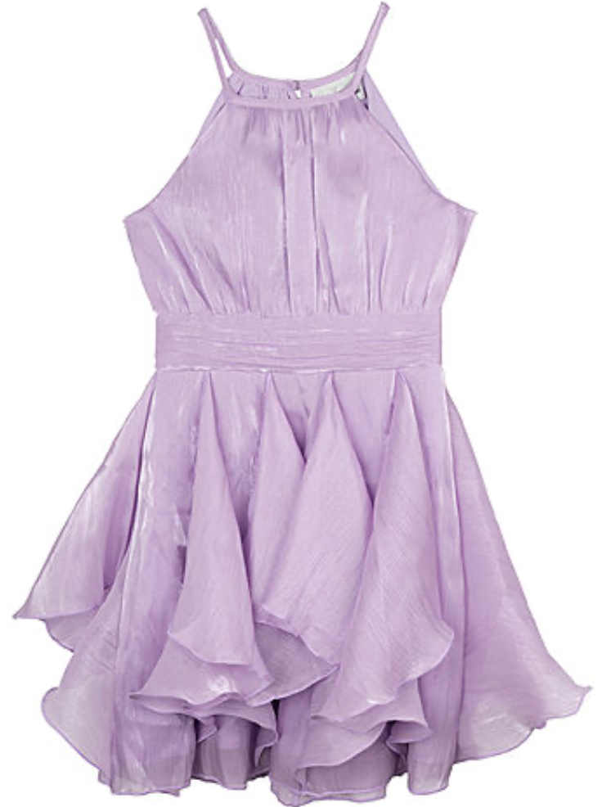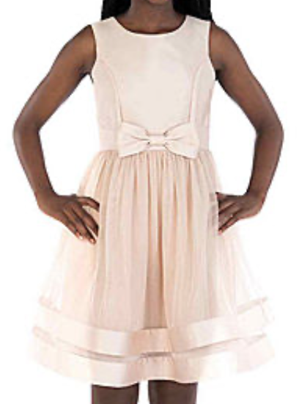

Miss Emma’s Classes
Class: Contemporary 4
Piece Title: “You’re Too Precious”
Look Description:
- Long sleeve top + pants
- All in cobalt blue
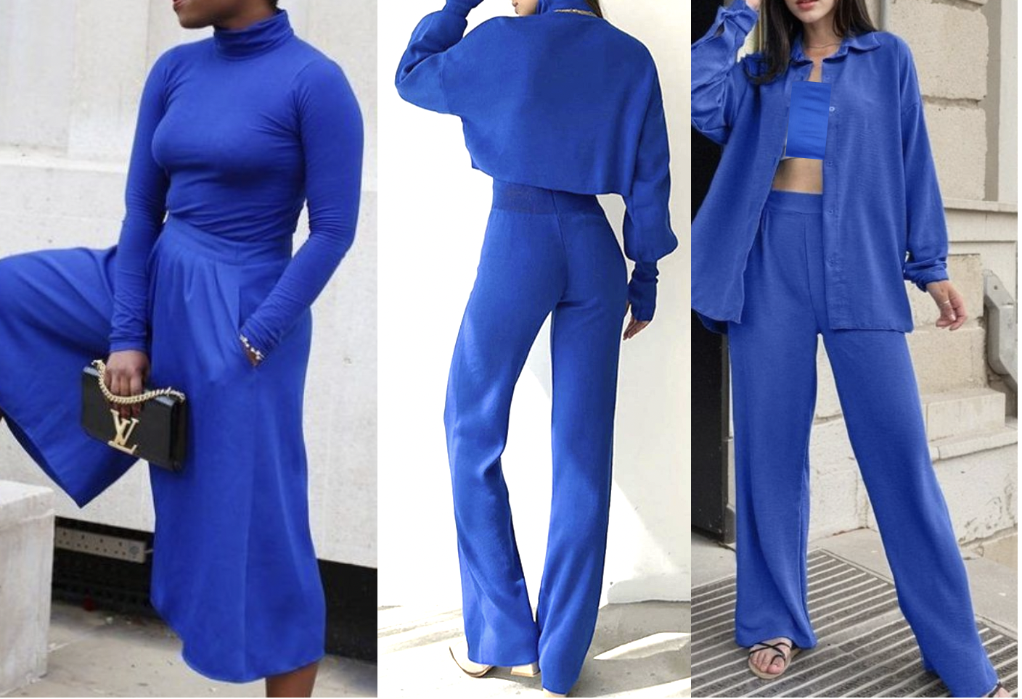

Class: Contemporary 3
Piece Title: “1234”
Look Description:
- Sundress (at or above knees) OR top and shorts
- All pieces in a sunflower yellow color
  - Should be a warm, rich yellow (no pastel or neon please)
- Textured fabrics are fine, but no prints / graphic patterns please

Class: Jazz 5
Piece Title: “Ya Ya”
Look Description:
- Mix of denim and white tops and bottoms
- White cowboy hat
  - **make sure to get one with a string so you can secure / pin it**
- Pops of red (e.g., bandana tied around neck, tank or crop top underneath denim vest, etc.)

Class: Jazz 6
Piece Title: “I’m Gonna Haunt You”
Look Description:
- Ladies:
  - Black, long sleeve top with flared or bell sleeves
    - Could be a long sleeved mesh top layered over a solid crop top as well (feel free to mix textures / fabrics) - examples in picture below
  - Black, flared jazz pants
- Jimmy:
  - Black long sleeve top, should be tighter / more fitted
  - Black pants, preferably a straight leg cut (not a jogger with tight cuff/narrow)
l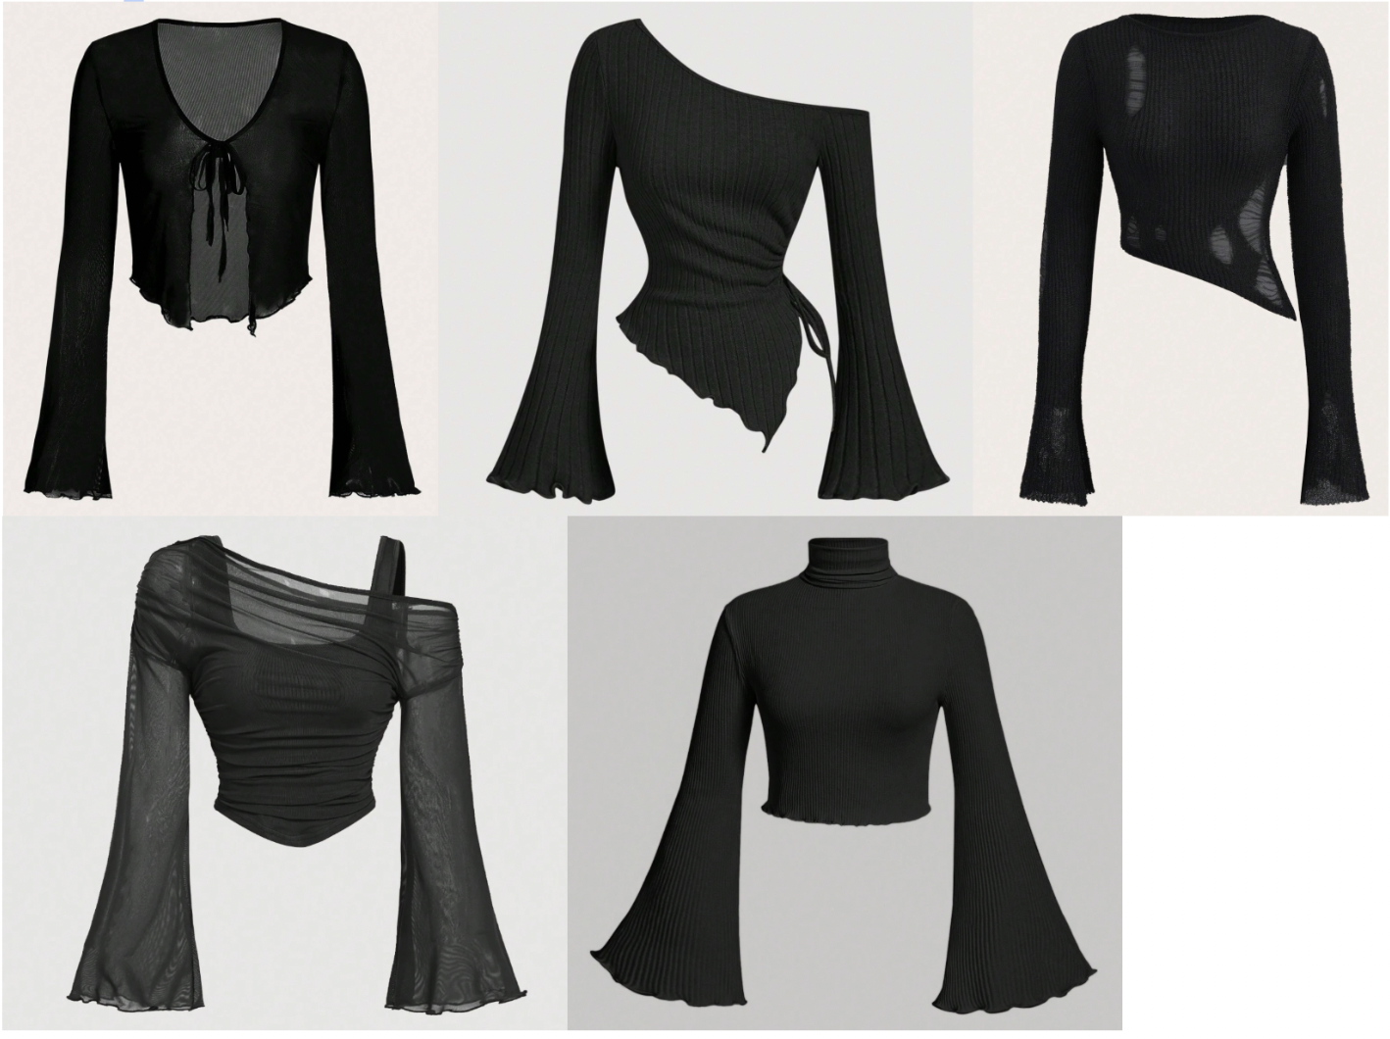

Miss Fatima’s Classes
Class: Contemporary 6
Piece Title: “Business of Misery”
Look Description: Business attire - Top in the colors red, black and white, think button-ups, turtle necks, suspenders, blazers, ties, and vests. Bottoms should be black slack pants.
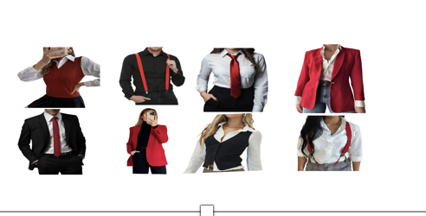

Class: Contemporary 5
Piece Title: “We’re Doing Fine”
Look Description: Spring/summertime outfit that you would wear outdoors/to a park etc that incorporate both white and lavender.
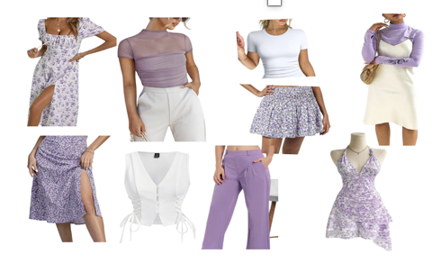
Miss Jordan’s Classes
Class: Contemporary/Jazz 3 (Thursday)
Piece Title: “Old Friends”
Look Description: pink pastel skinny strap dress (nothing long, should hit above the knee) with either pink pastel shorts or leotard under.
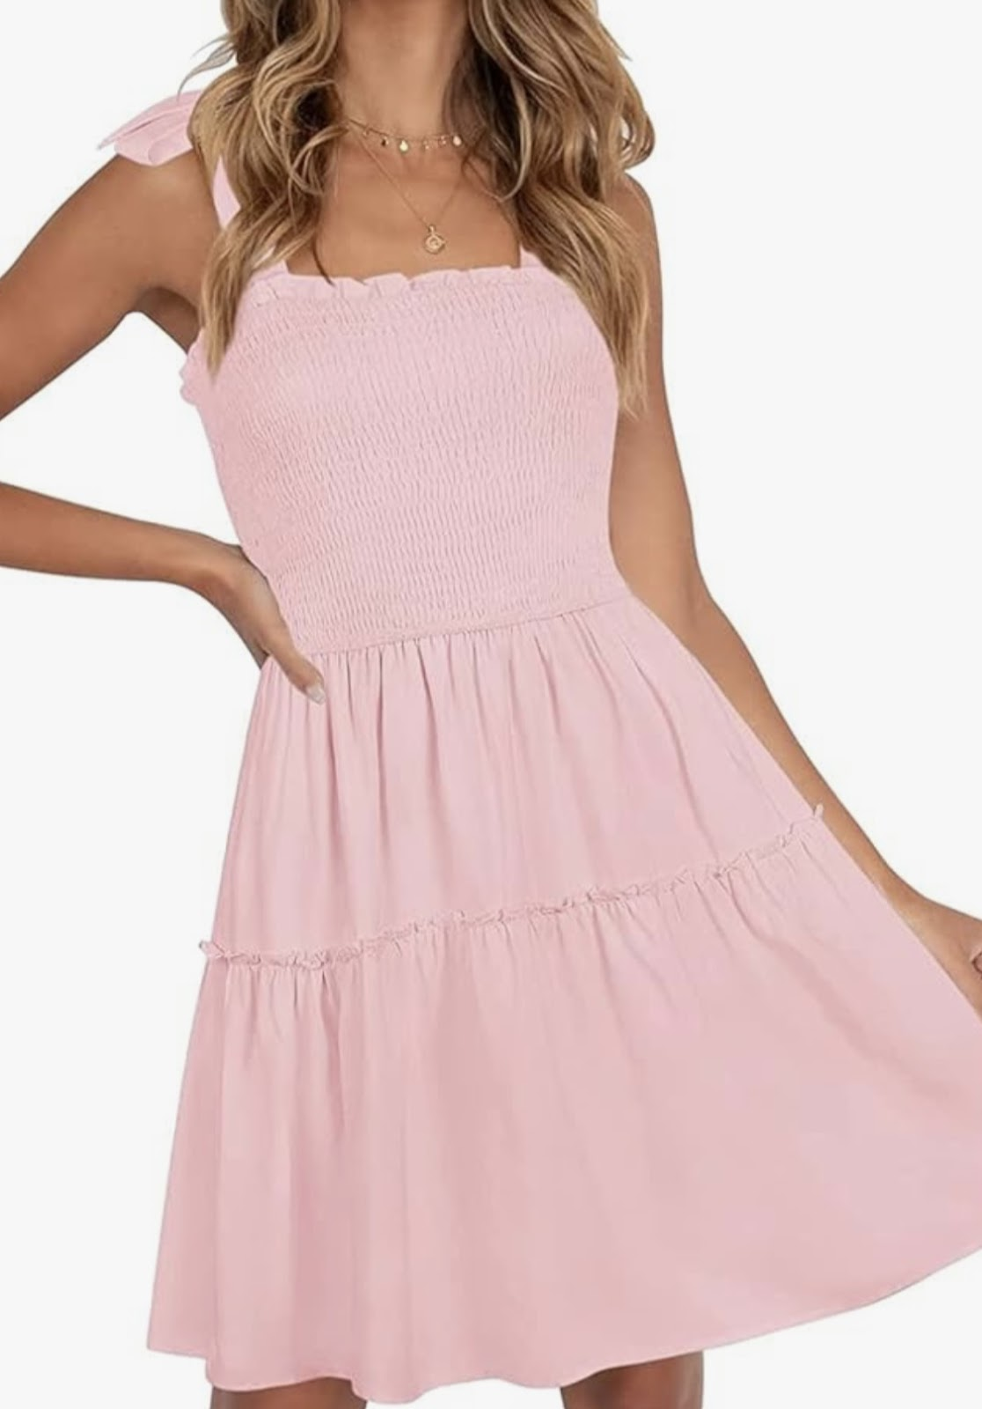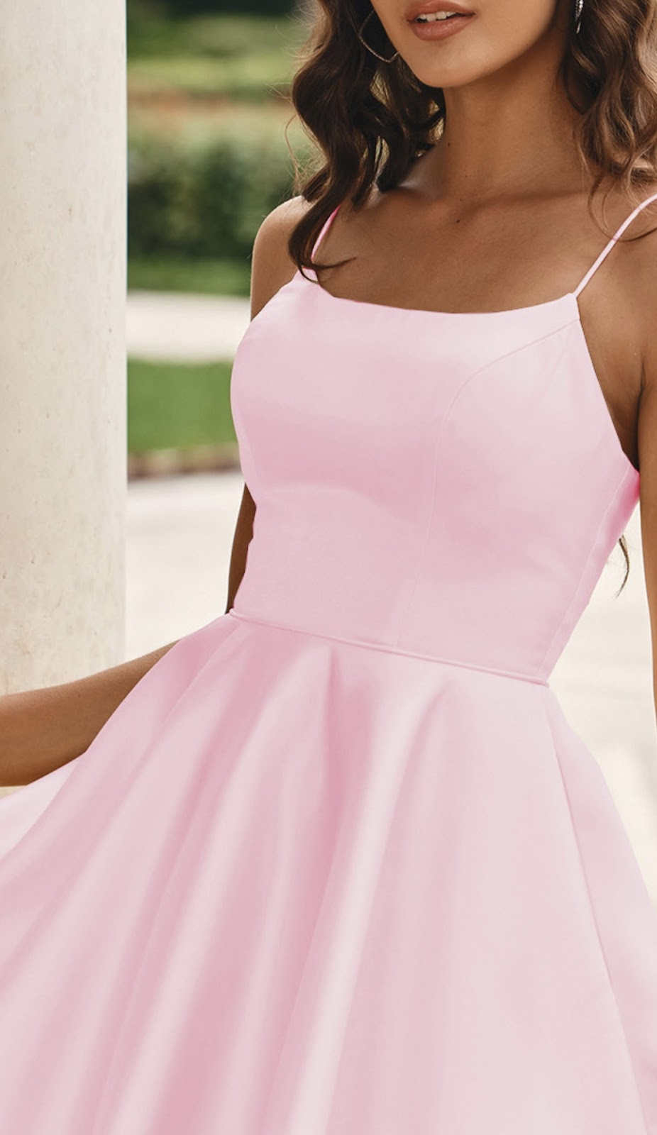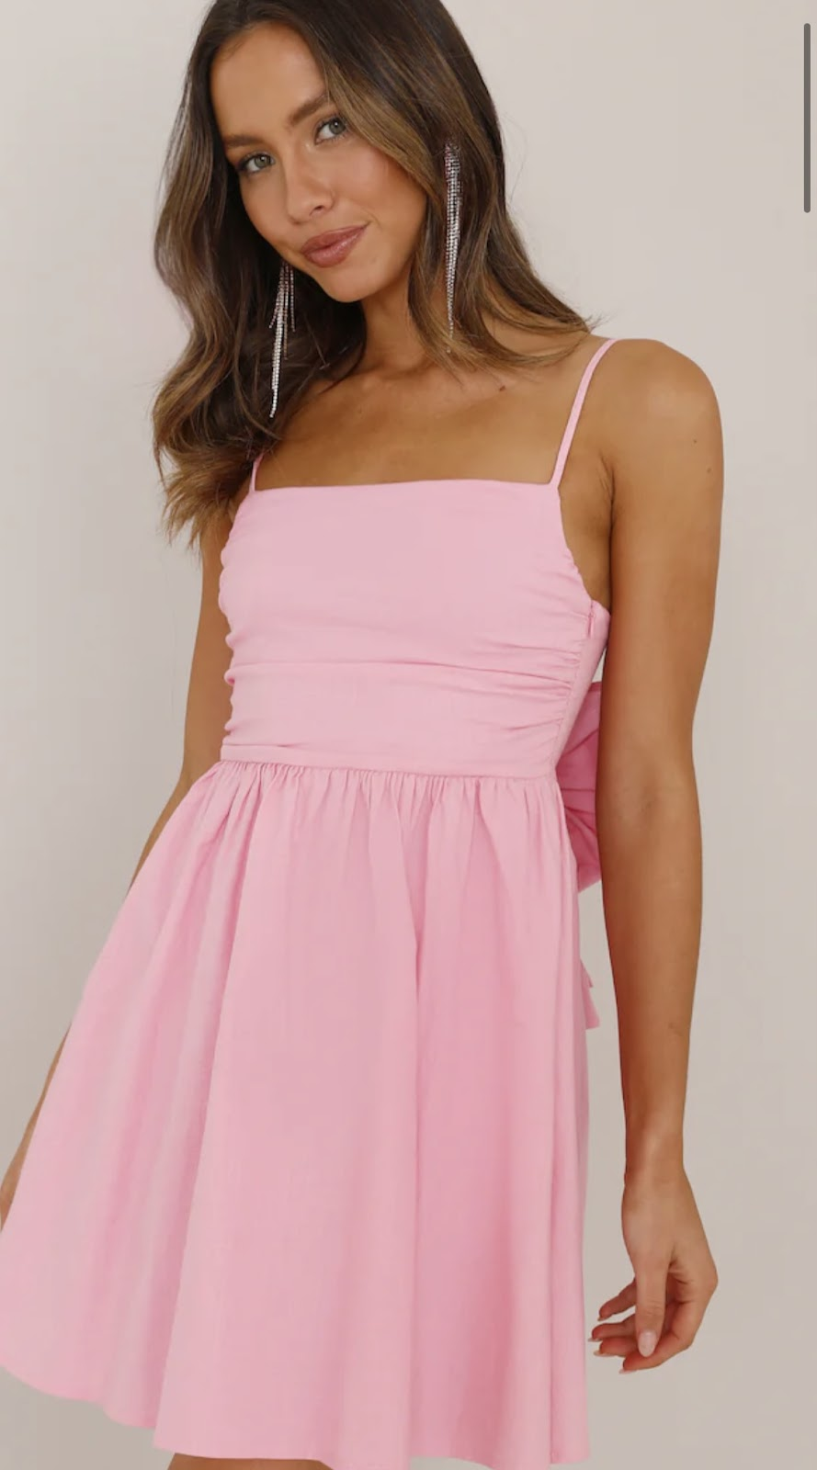

Kaylan’s Classes
Class: Hip-Hop 2 A/B
Piece Title: “4ever”
Look Description: LIGHT blue, purple, yellow, or pink crew neck sweatshirts, and denim bottoms ( loose/ baggy preferred) White sneakers.

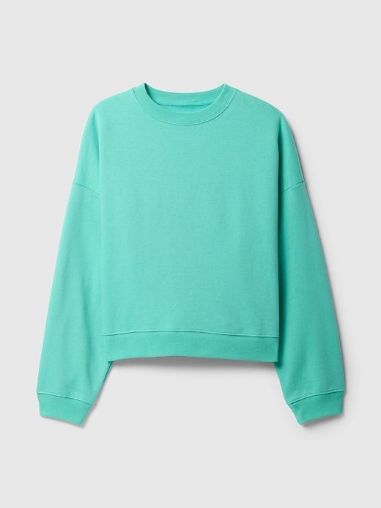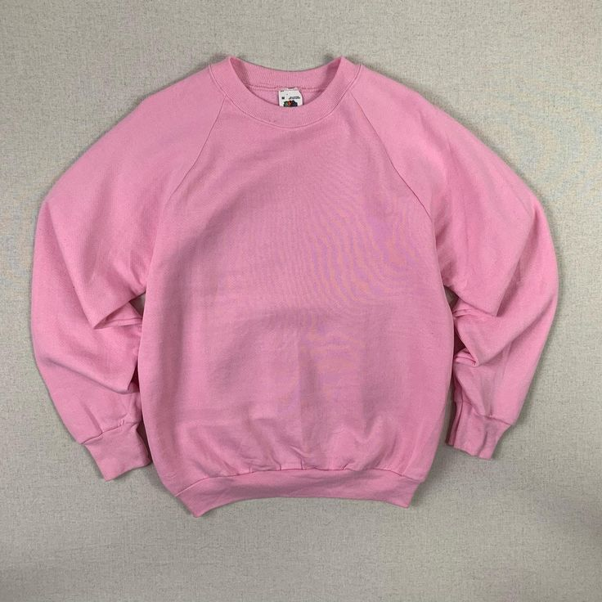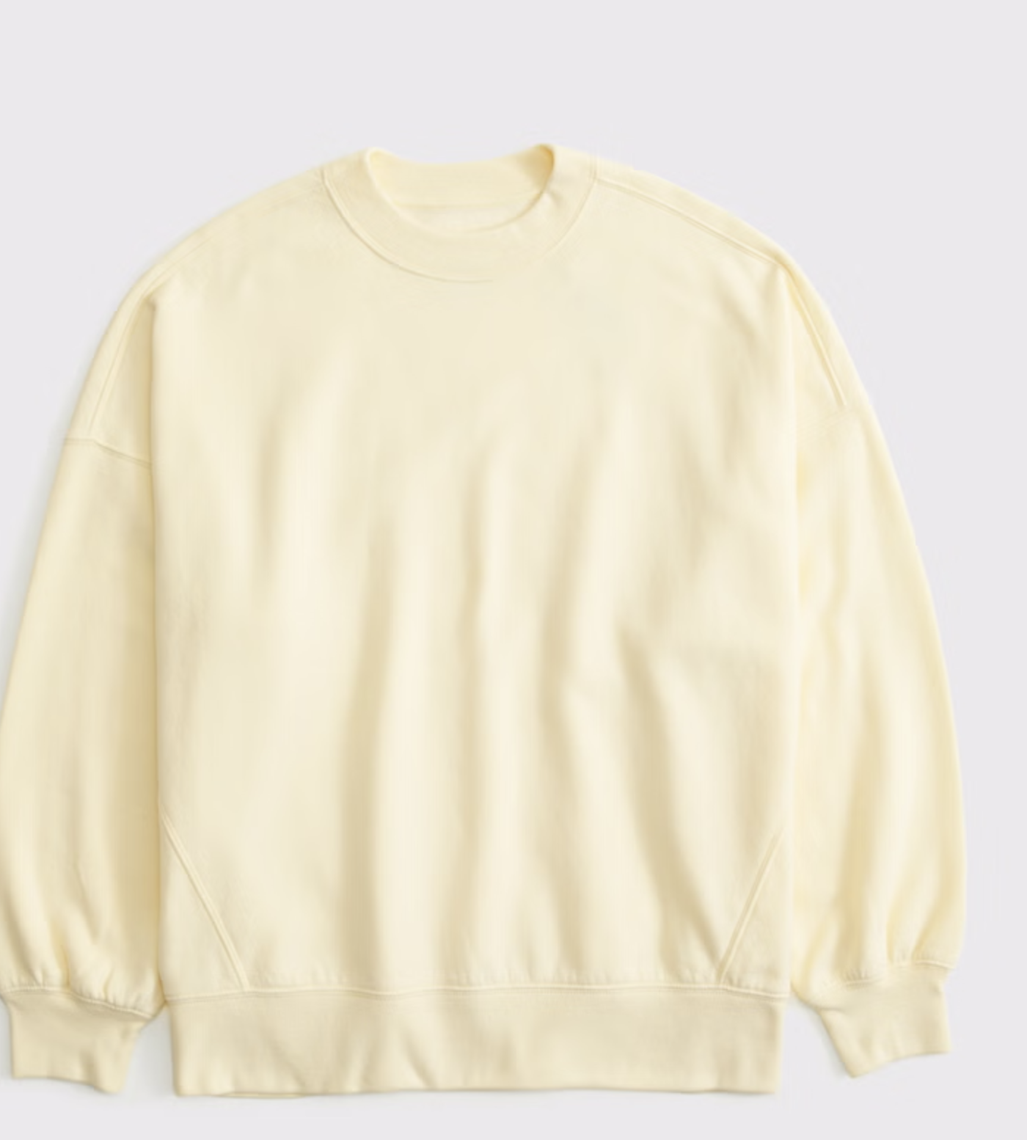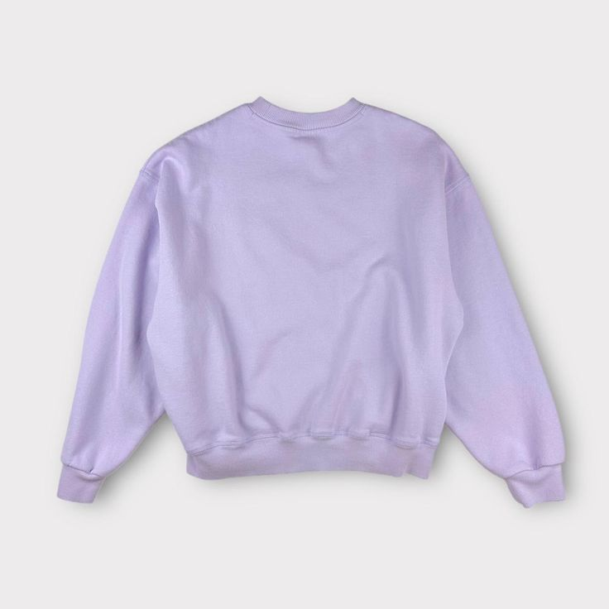

Class: Hip-Hop 3
Piece Title: “Mine”
Look Description: Pink and white outfits, baggy pants (cargos, sweats, etc) and white tops (tees, long sleeves, jerseys, etc) - if dancer would prefer to wear white bottoms and pink top that is also great!
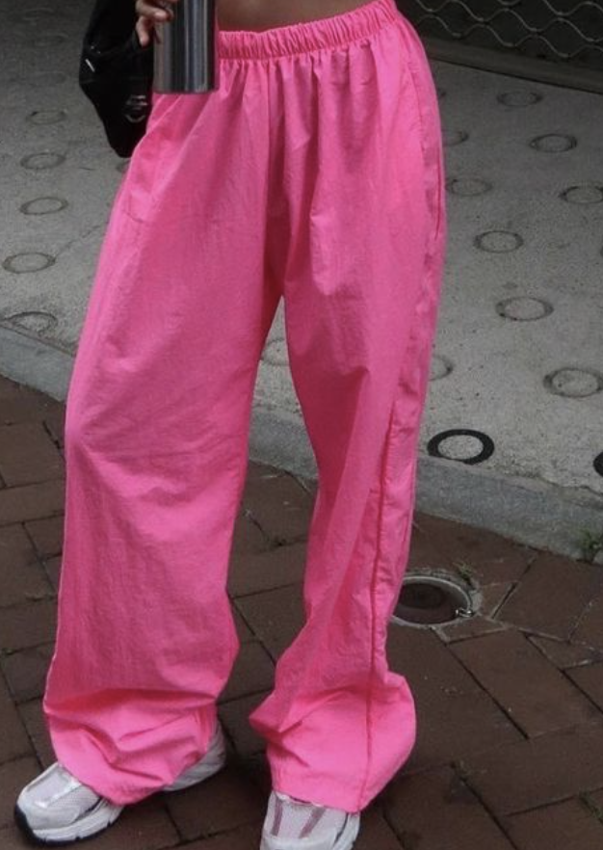

Class: Hip-Hop 4
Piece Title: ”Ice Cream Paint Job”
Look Description: Baggy Denim Bottoms (shorts or full jeans), white tees (can be baggy or fitted), white sneakers preferred
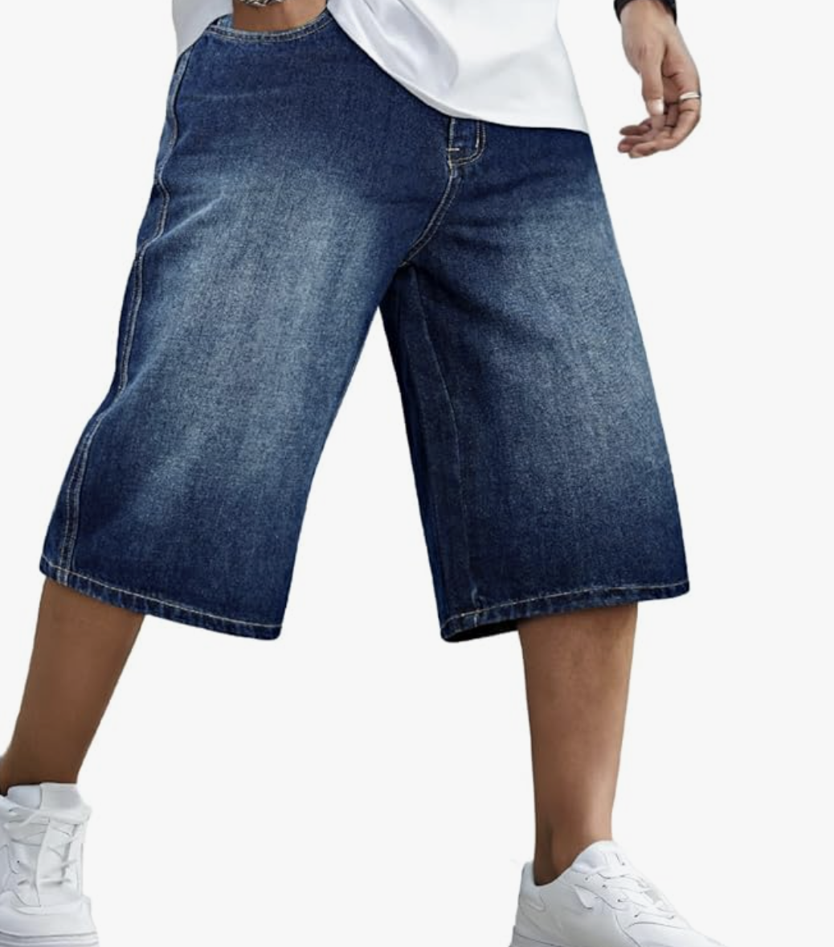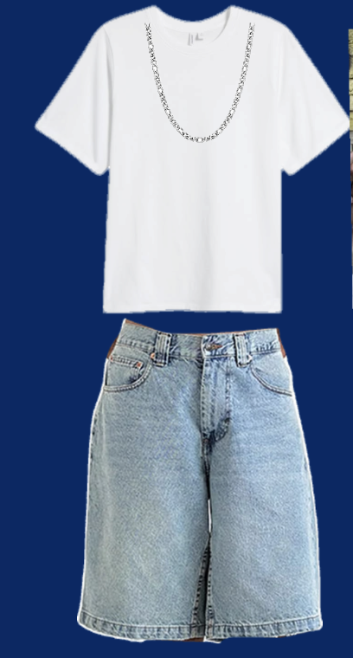

Class: Hip-Hop 6
Piece Title: “A Problem”
Look Description: a creative and comfortable spin on suit pieces/ separates. Colors include black, grey, navy blue. A base of slacks/ pleated pants that are comfortable to dance in, and white button downs, vests, suit jackets, ties, etc - white or black sneakers
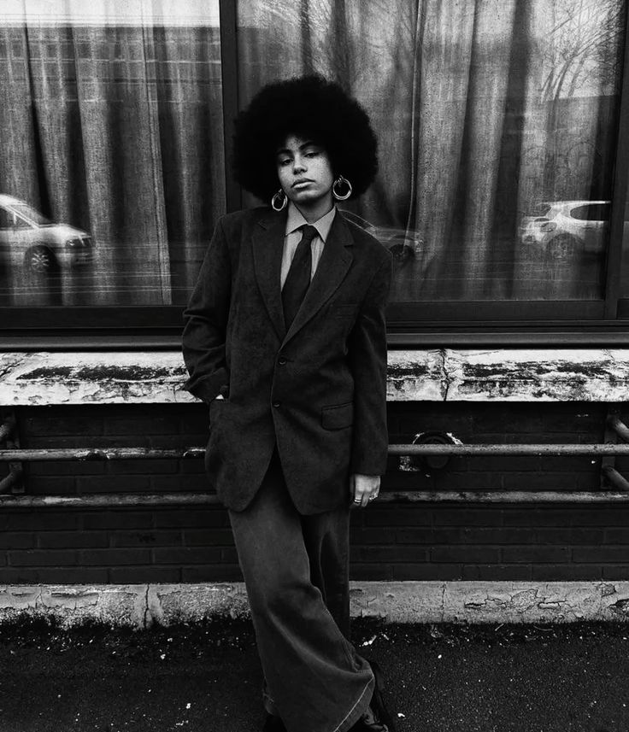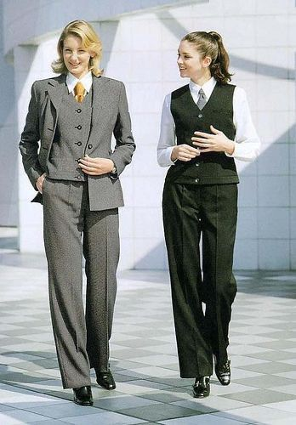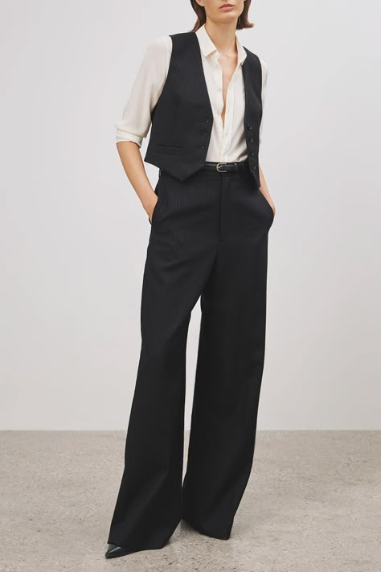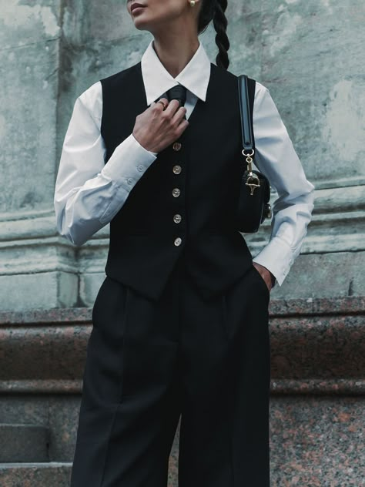

Class: Hip-Hop 5
Piece Title: “Hey Now”
Look Description: Royal/ cobalt blue matching sweatshirts and sweatpants, white sneakers preferred, hats and accessories in blue or white are encouraged!
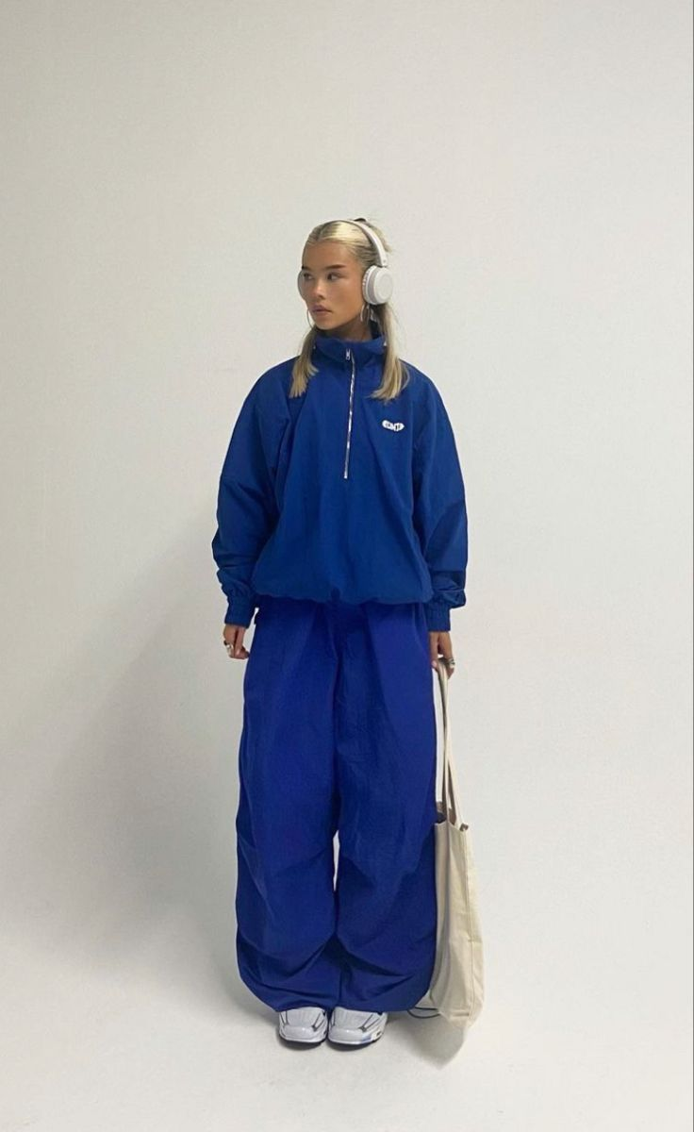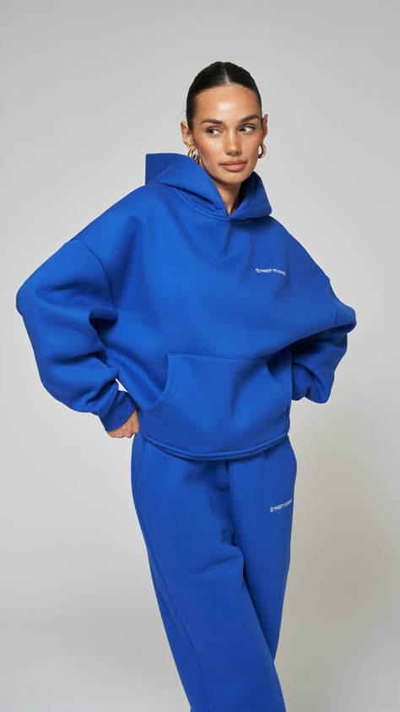

Miss Krista’s Classes
Class: Jazz 4
Piece Title: “Rumble”
Look Description: Army camo and black (must include both)
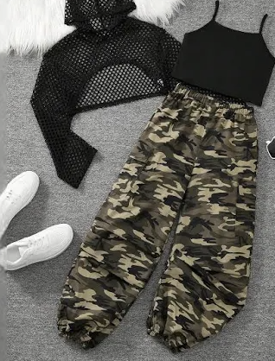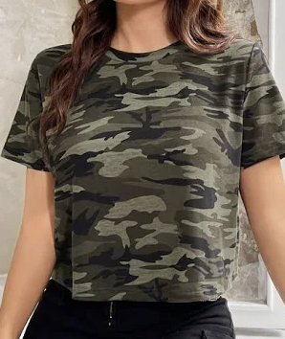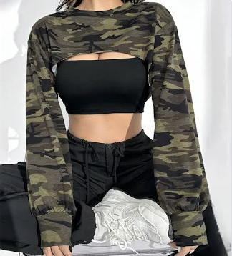

Miss Nicole’s Classes
Class: Jazz 2
Piece Title: “Dancing in the Street”
Look Description: Black flare dance pants, neon color top (pink, green, purple, yellow, or blue)

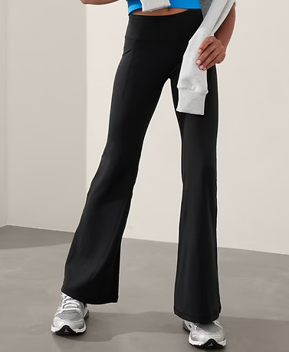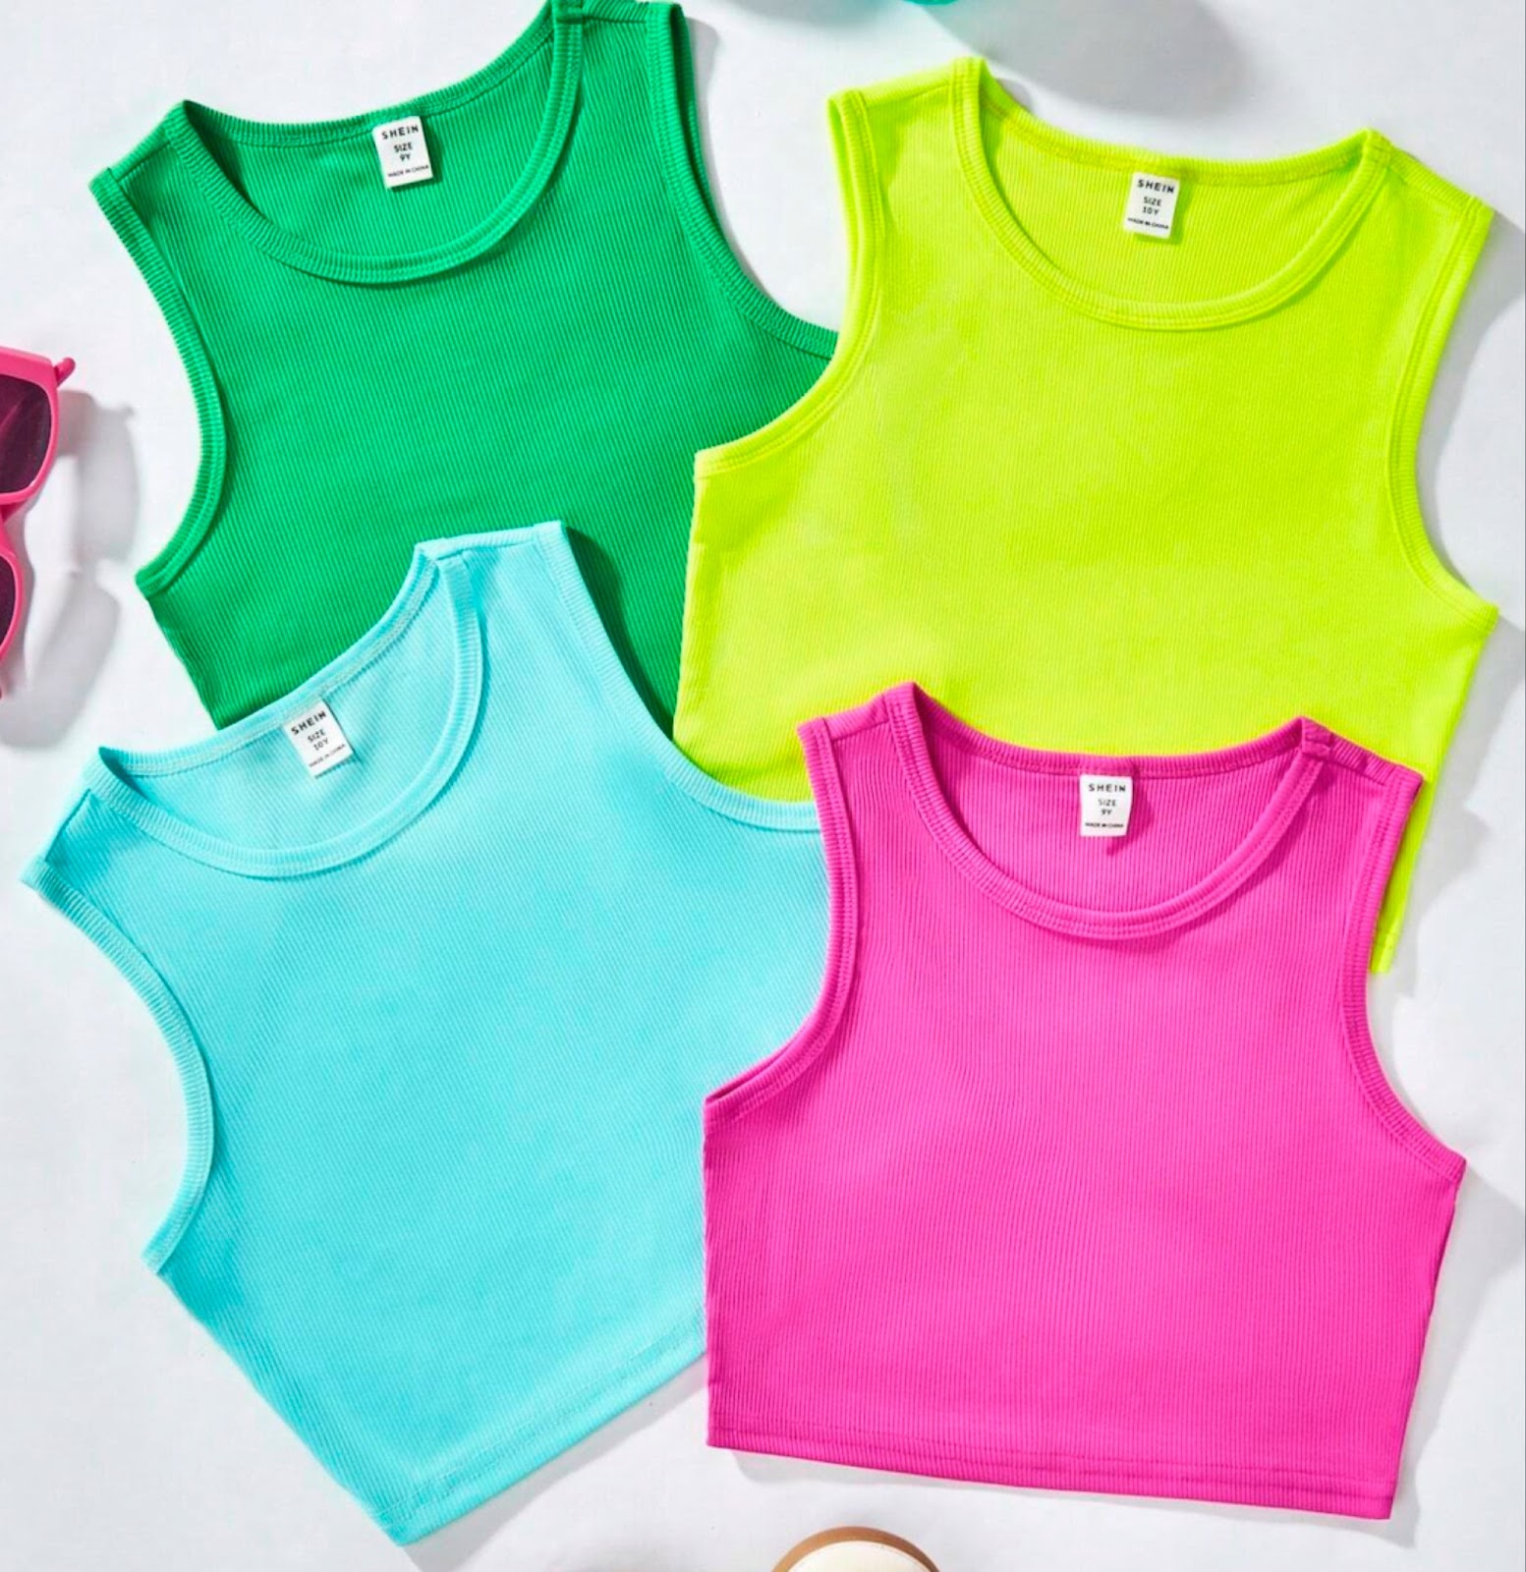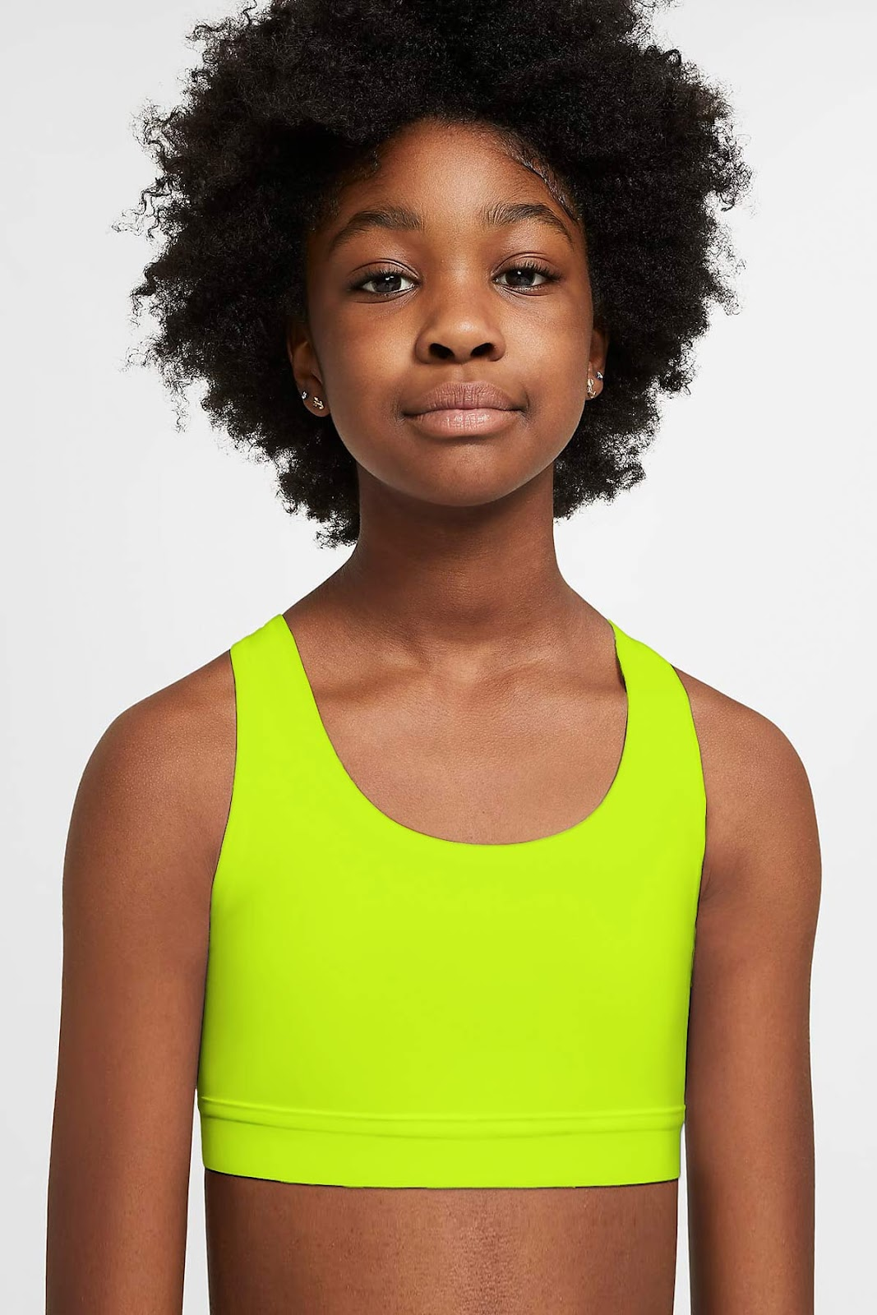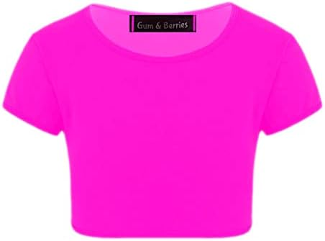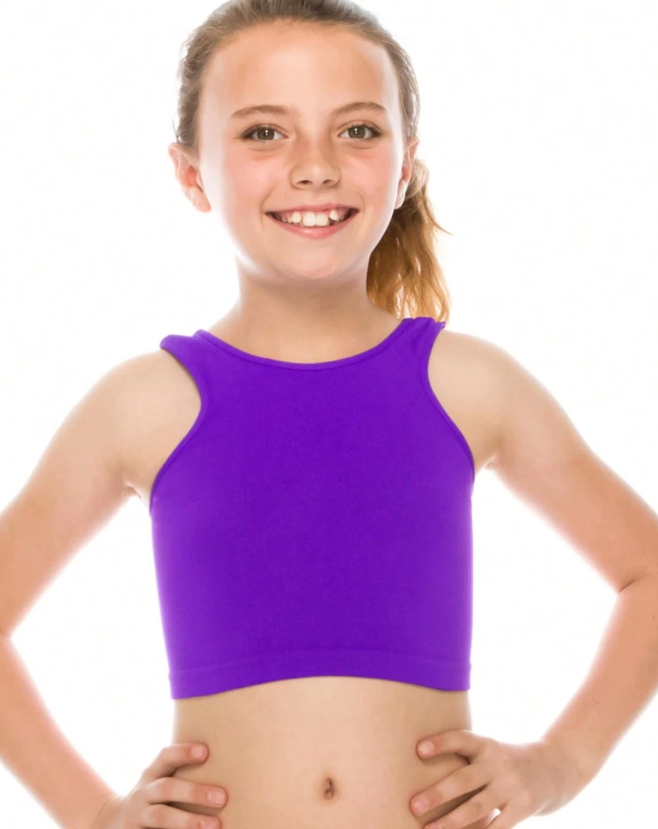

Class: Jazz 3
Piece Title: “SOS”
Look Description: All white outfit (must be pants) - think vest/top and pants or jumpsuit plus gold hoop earrings

