Creative Costuming Revue 2024

MISS AJ CLASSES
Class: Tap 2/3
Piece Title: Ain’t Nothing Wrong with That
Look Description: Neon Rockstar vibes
- Black jeans (no leggings please)
- Black dress socks
- Neon shirt- no long sleeves please
Kate, Kaelyn, Makayla, and Amy- neon pink
Addison, Lily, Rowan, and Harper- neon green
Ava, Lauren, and Karolina, neon yellow
Harper, Daphne, Valentina- neon orange
- 2-3 ‘rockstar’ accessories- could be fingerless gloves, black vest, neon hair clip or neon jewelry, bandana, studded belt
Pictures for example:
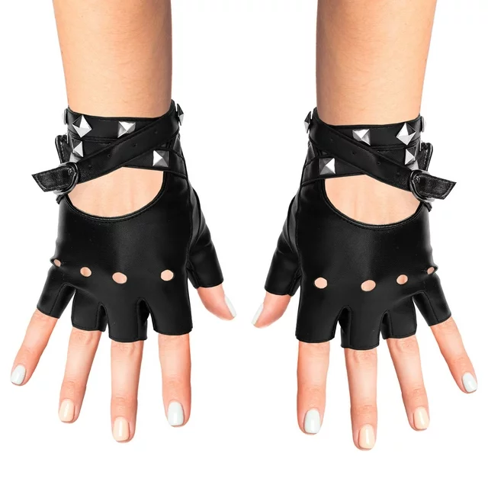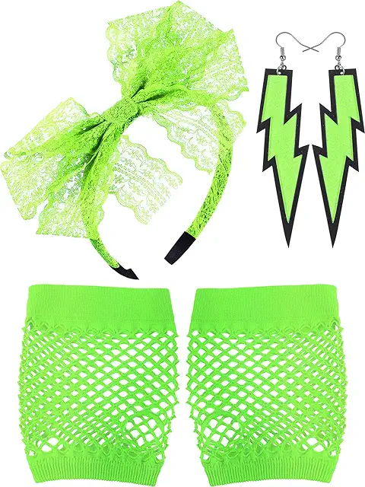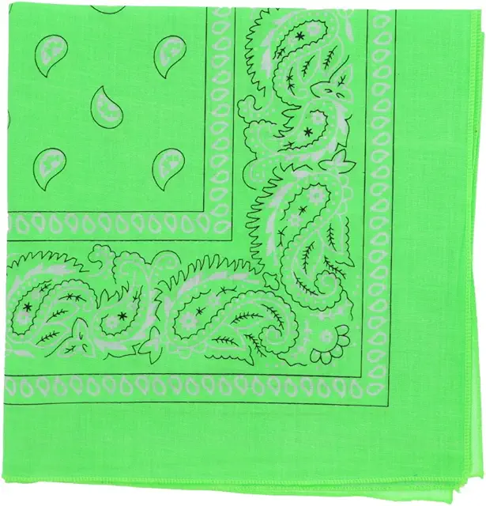

Class: Tap 4
Piece Title: Wishin’ and Hopin’
Look Description: Girls night in. Matching silk pajama sets. Eye masks, friendship bracelets, headbands, etc. Robes as long as they’re also pink
- Matching silk pajama set. Patterns or stripes are ok. Shorts and pants are ok.
- 1-2 ‘sleepover’ accessories
- No-show socks
Color Family: Shades of pink
Pictures for example:
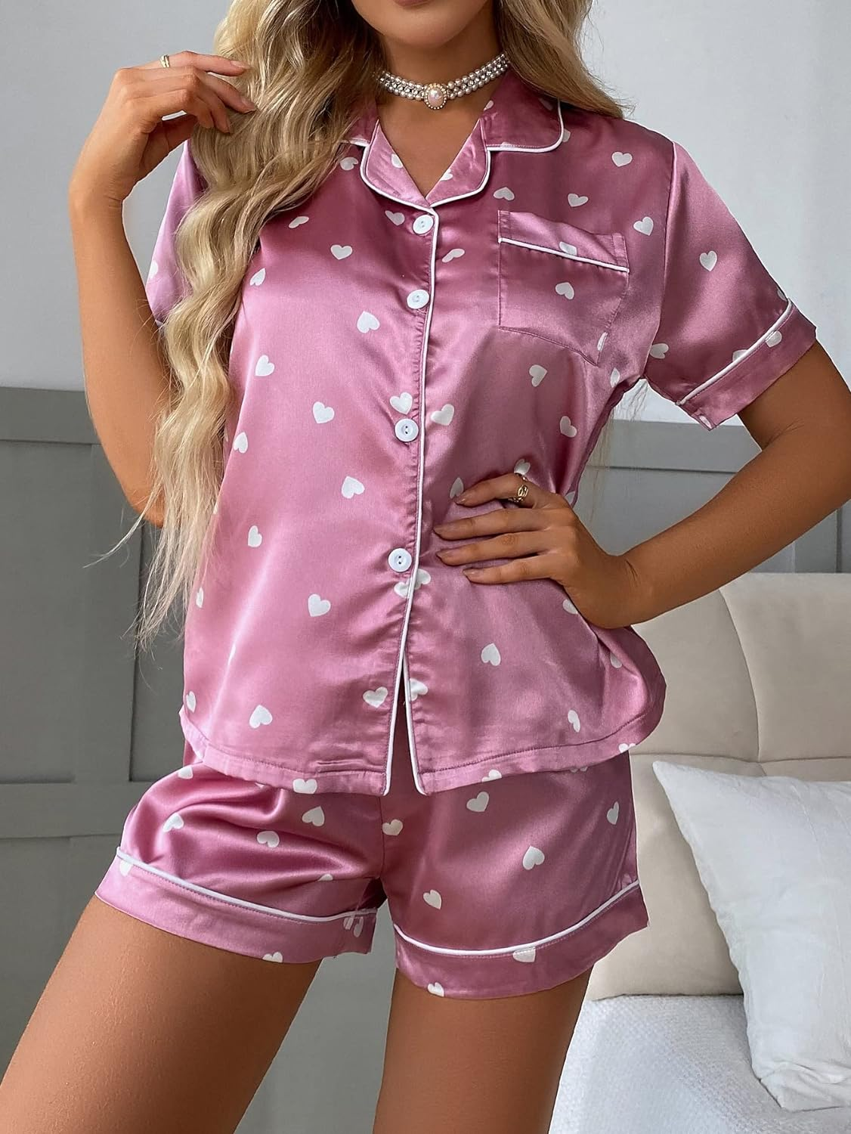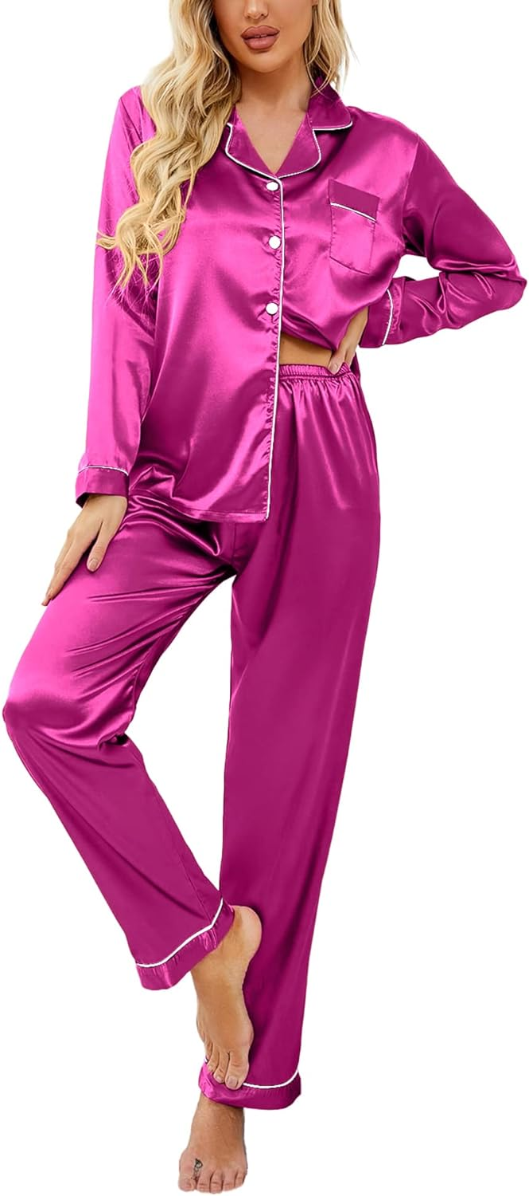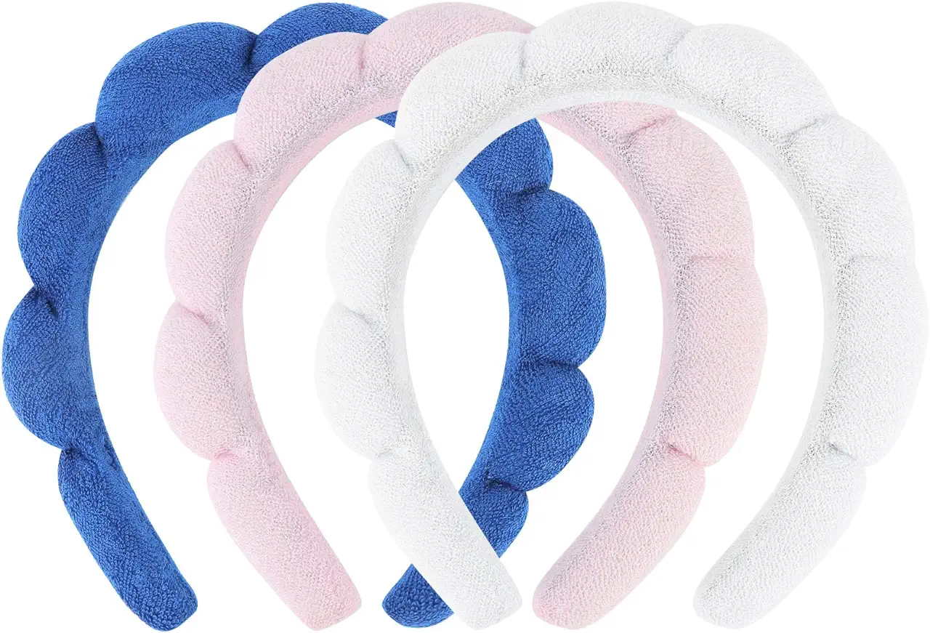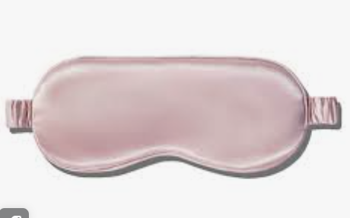

Class: Tap 5/6
Piece Title: Jolene
Look Description: Western. Denim “tuxedos,” or blue denim top and blue denim jeans. They do not have to match exactly, but I would like them to be close.
- Denim top
- Jeans, cropped ankle or full length (holes/fraying okay)
- Black belt
- Red handkerchief for everyone except HS seniors:
  - Sade and Olivia- White handkerchief
  - Anna and Ace- Black handkerchief
Color Family: All blue denim from light wash to dark wash, but no black please
Pictures for example:
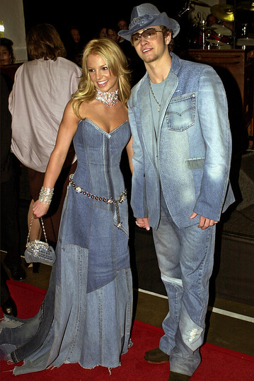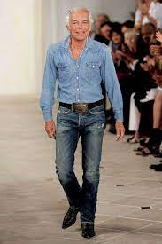

MR DAVID CLASSES
Class: Hip-Hop 3
Piece Title: Knockout
Look Description: Boxers, please purchase from links provided, if not available in your size, please purchase something as similar as possible. Wear tall white socks, options for footwear: all white, all black, or black and white sneakers.
Color Family: red, black, white
Robe
Shorts
Top
Gloves
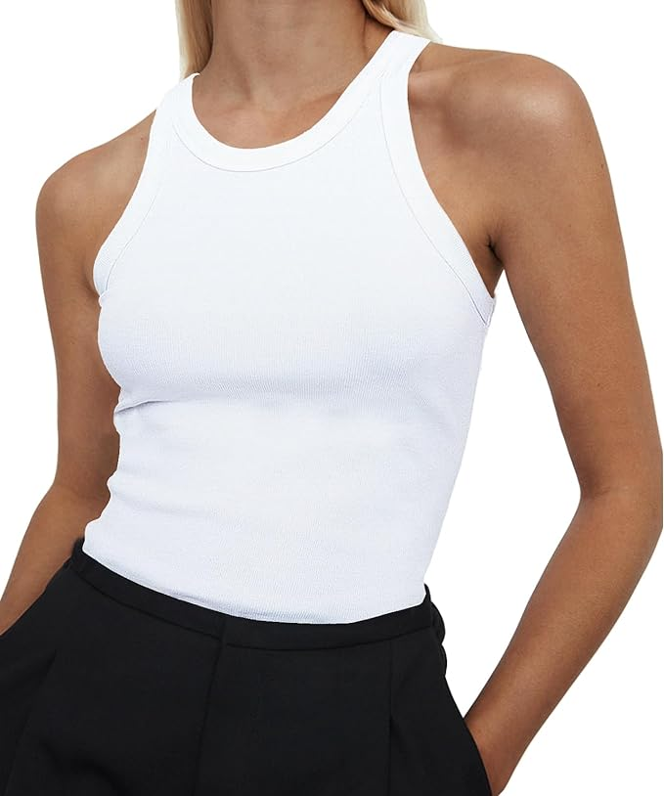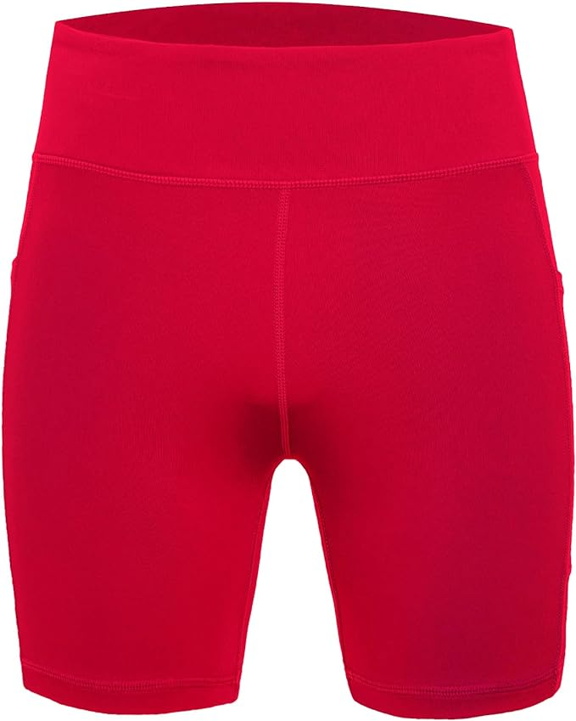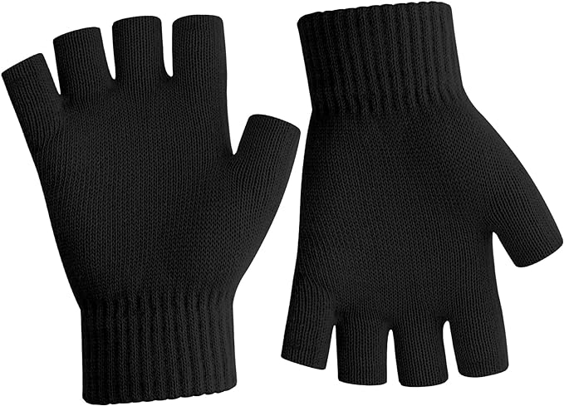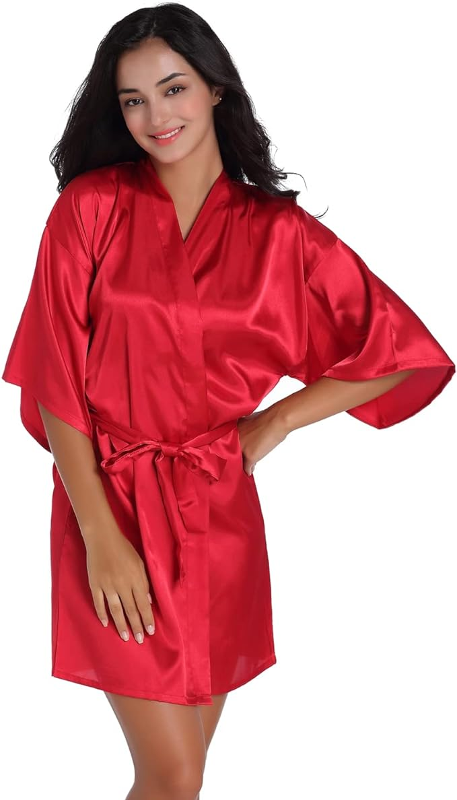

Class: Hip-Hop 4
Piece Title: On Wednesdays We Wear Pink
Look Description: pink mean girls vibes. Show your personality with your costume. Does Not need to be a skirt, can be shorts, cargos, sweats etc. layer and add any accessories you want. Shoes are white or white and black
Color Family: Pink, white, black
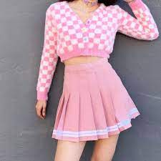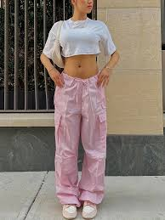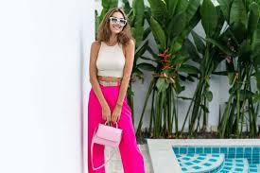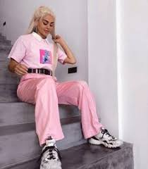

Class: Hip-Hop 5
Piece Title: Wonka
Look Description: Wonka. Follow below links for items. Please read carefully as some dancers have their own set of items. Shoe options: all white, all black, or black and white sneakers
LAYLA, EVA, SOMEE, CYMONE, LILY, NYRA, TEAGEN, KATIE:
top
Pants
Bandana

JIMMY, CHARLIE (here are examples, please work together to purchase similar items)
Vest
Pants

JOANNA, ANNABELLE
Dress
Shirt
Pants

LAUREN, NAOMI (DECIDE WHO GETS WHAT COLOR DRESS - NO PURPLE)
Dress

NIYA, ADELAE (SAME COLOR TRACKSUIT)
Tracksuit

KENDALL, CARA (here are examples, purchase similar items)
Tee shirt
Shirt
Pants
Blazer
Pants

KYLEE (FOLLOW PHOTO BELOW FOR EXAMPLE)
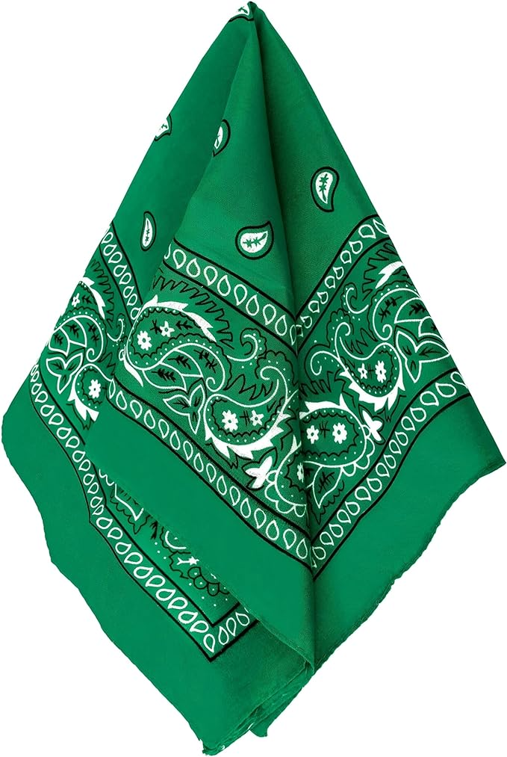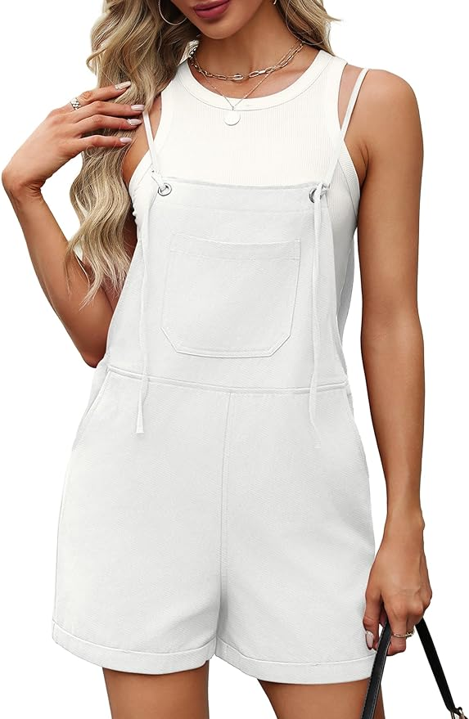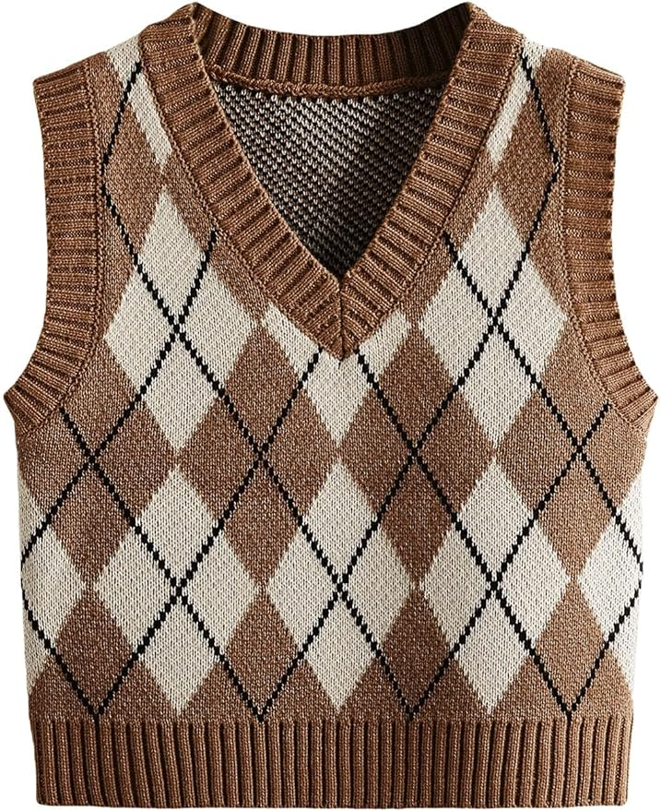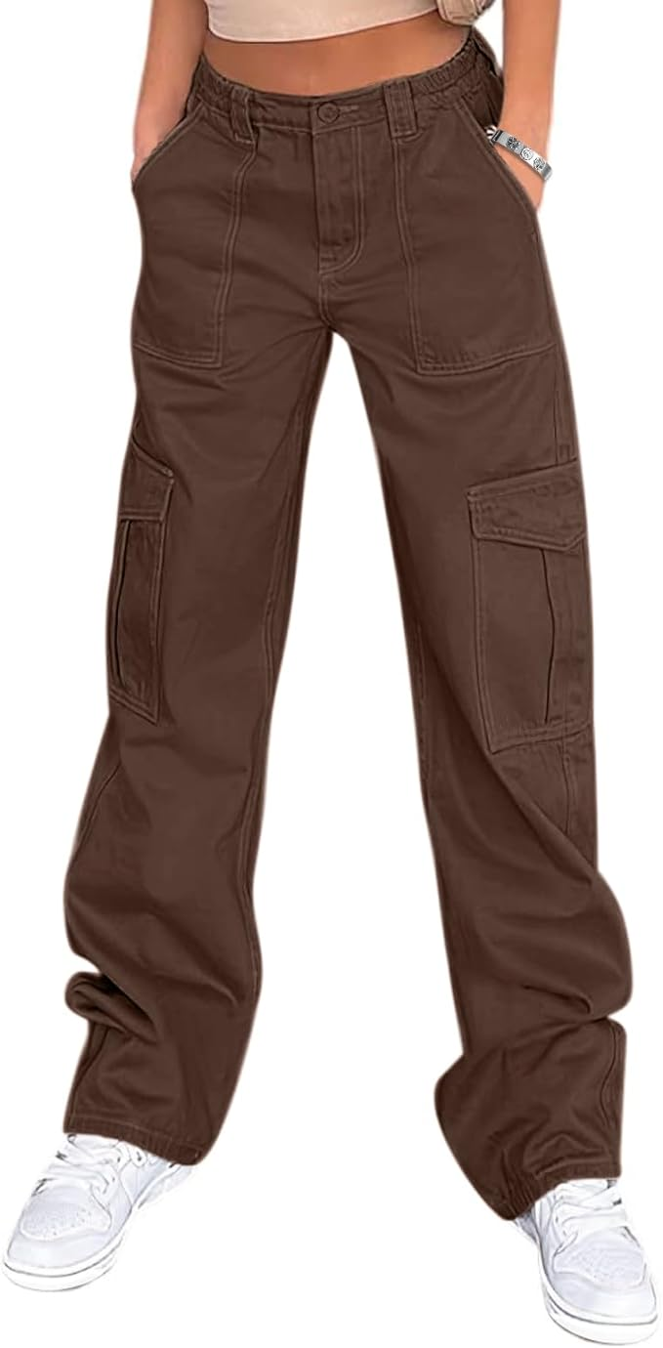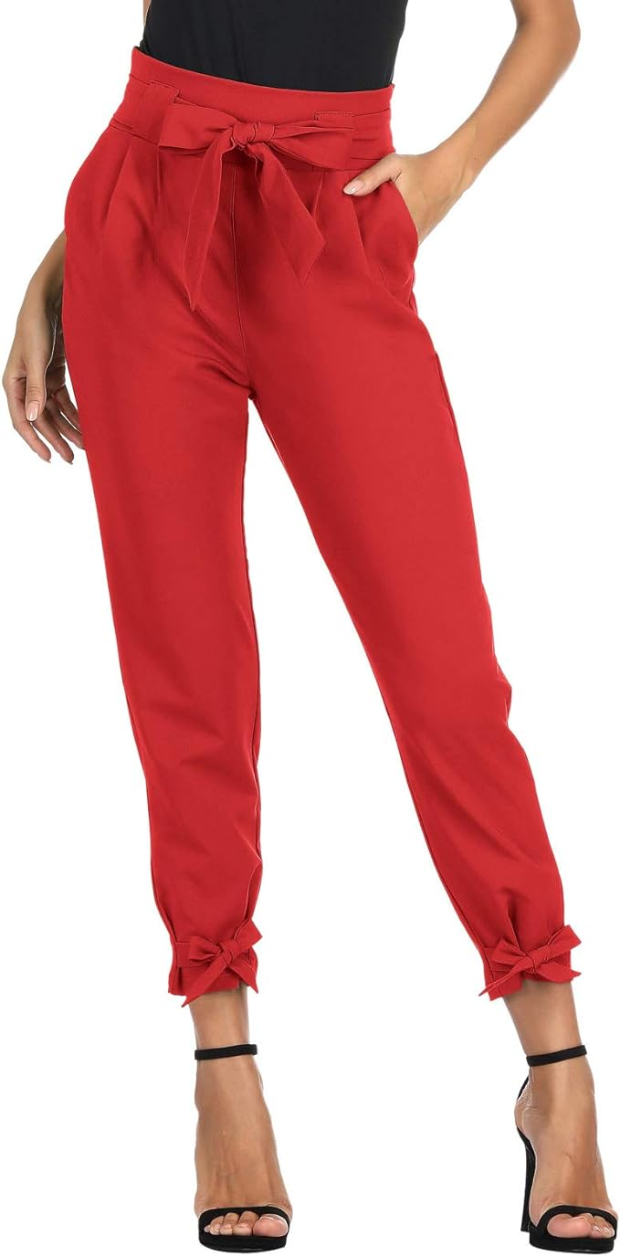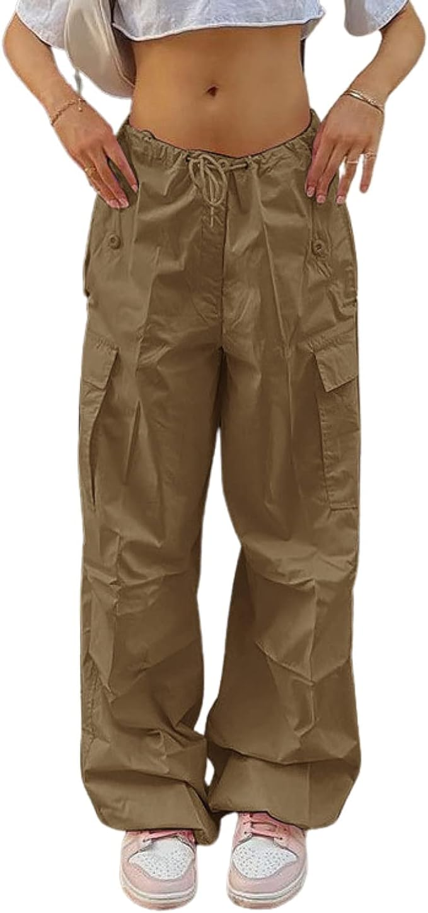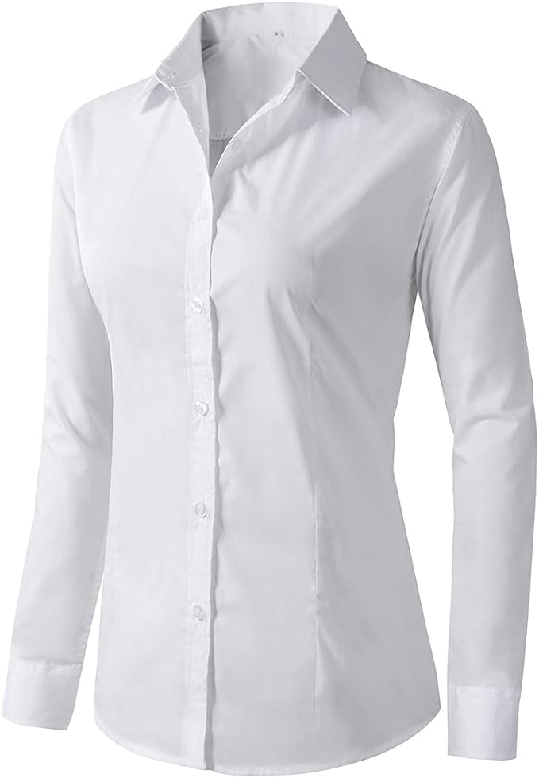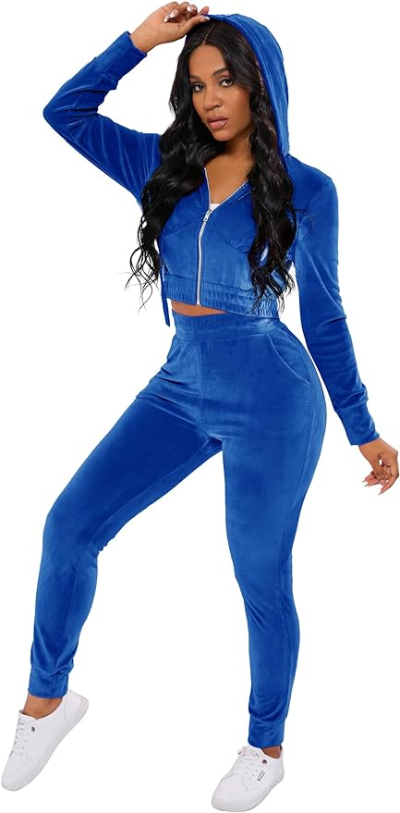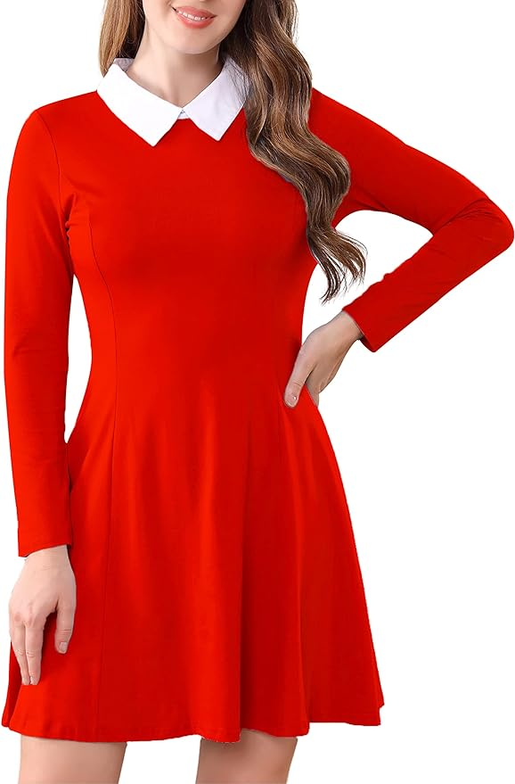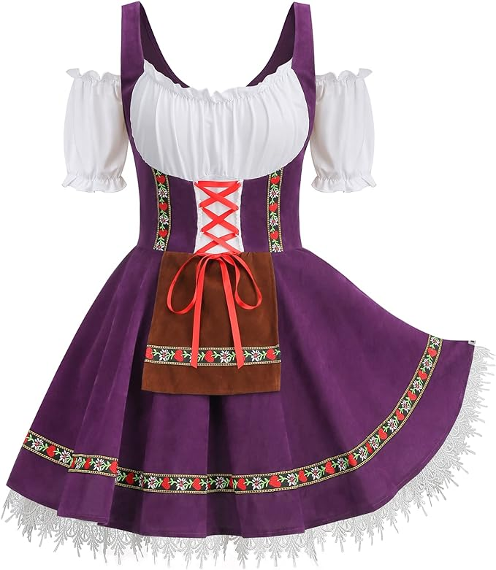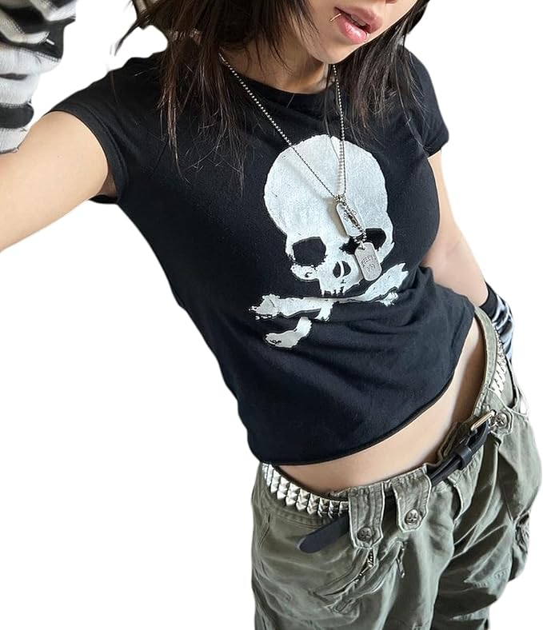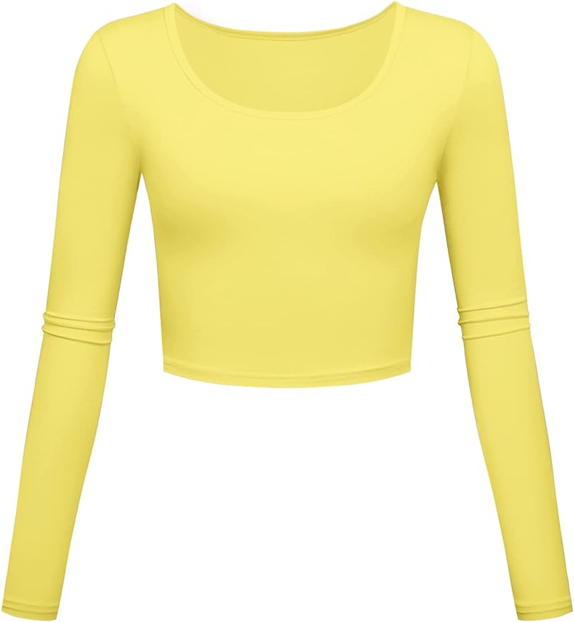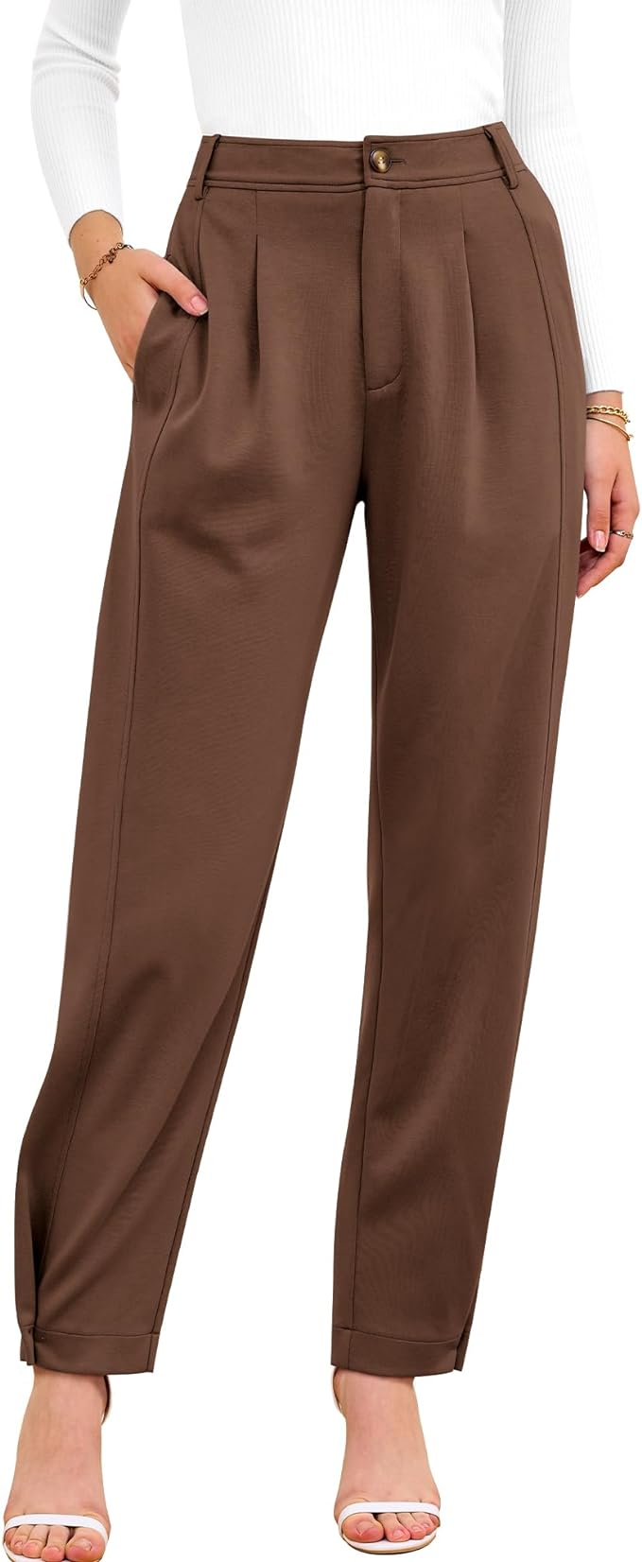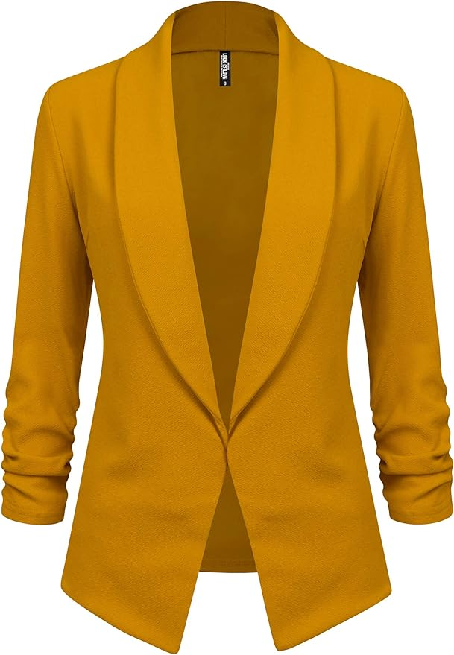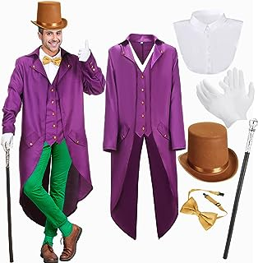

Class: Hip-Hop 6
Piece Title: Hunger Games
Look Description: Hunger games. Green cargo pant base, earth tone thin layer on top (no weapons please), thin jacket over top, black or dark shoes. Purchase these pants:
Cargo Pants
Color Family: black, green, burnt orange, red, grey, maroon
Pictures for example:
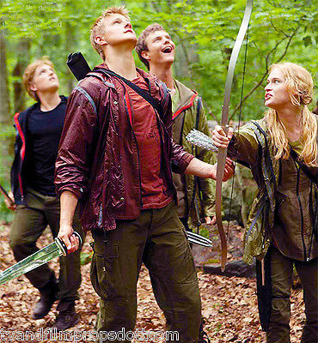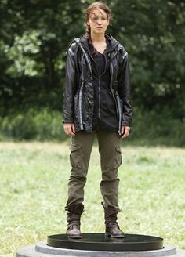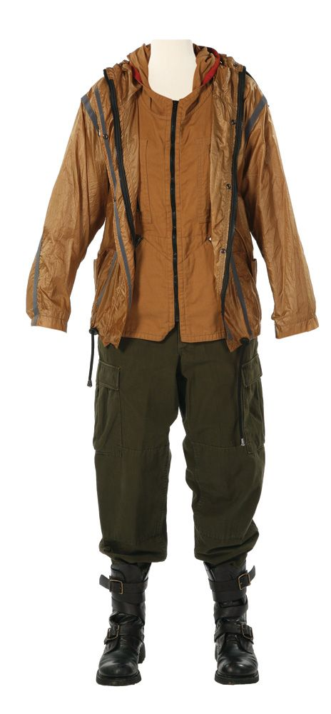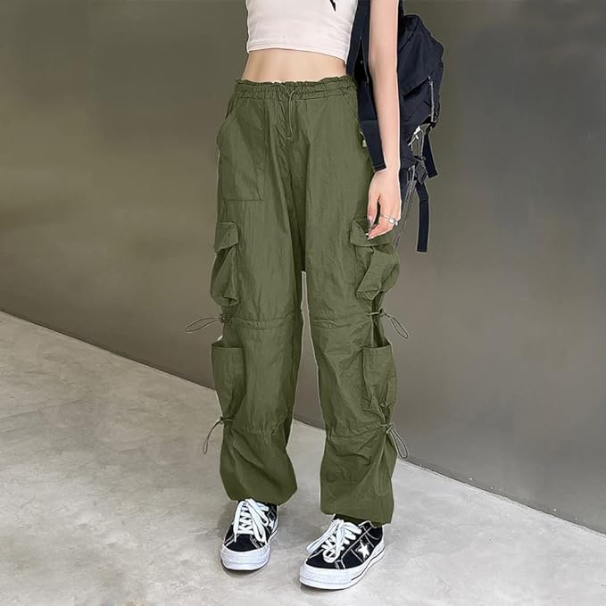

MISS EMMA CLASSES
Class: Jazz 6
Piece Title: No Problems
Look Description: 70s inspired orange separates (tops, jackets, pants, jumpsuits, etc.)
*Feel free to accessorize! (add a belt, scarf, extra layer, etc.)
Color Family: Bold, fiery oranges
Pictures for example:
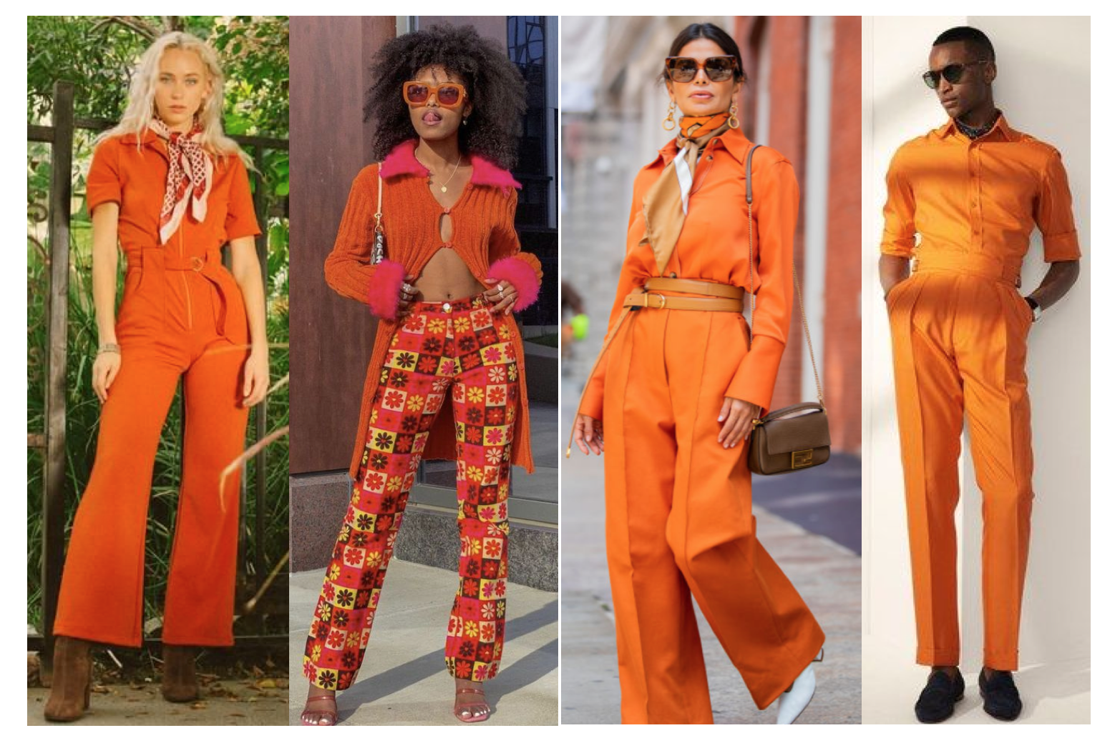

Class: Jazz 4
Piece Title: Hey There
Look Description: Short, above the knee dresses (can find at Lulus.com, Target, Amazon, ASOS, etc.)
Color Family: Red (stick to a true red, so no burgundy, coral, etc.)
Pictures for example:
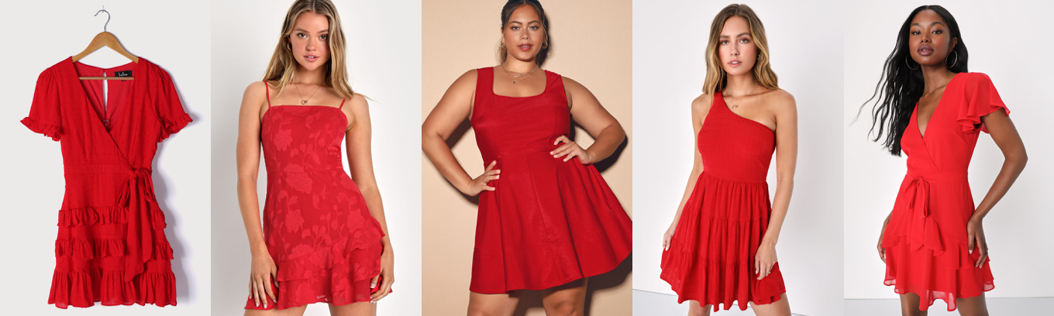

MISS JORDAN CLASSES
Class: Lyrical 2
Piece Title:
Look Description: Purple dresses/skirts and crop tops
Color Family: Purple (lilac, regal or mauve purple colors) no patterns please, keep attire to be more casual like

MISS JULIKA CLASSES
Class: Hip-Hop 2
Piece Title: Be Me
Look Description:
Top: Black and White Baseball Jersey (Make sure black tank or black leotard under jersey)
Bottoms: Khaki Pants
Shoes: Black and White
Pictures for example:
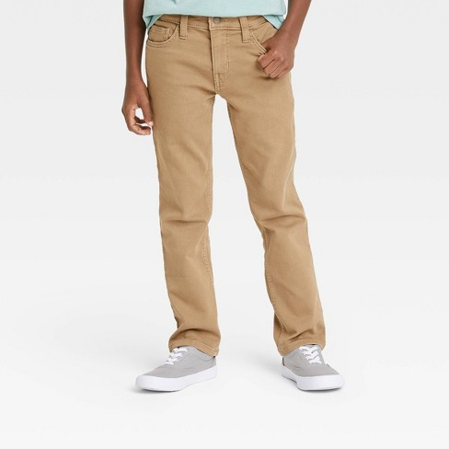
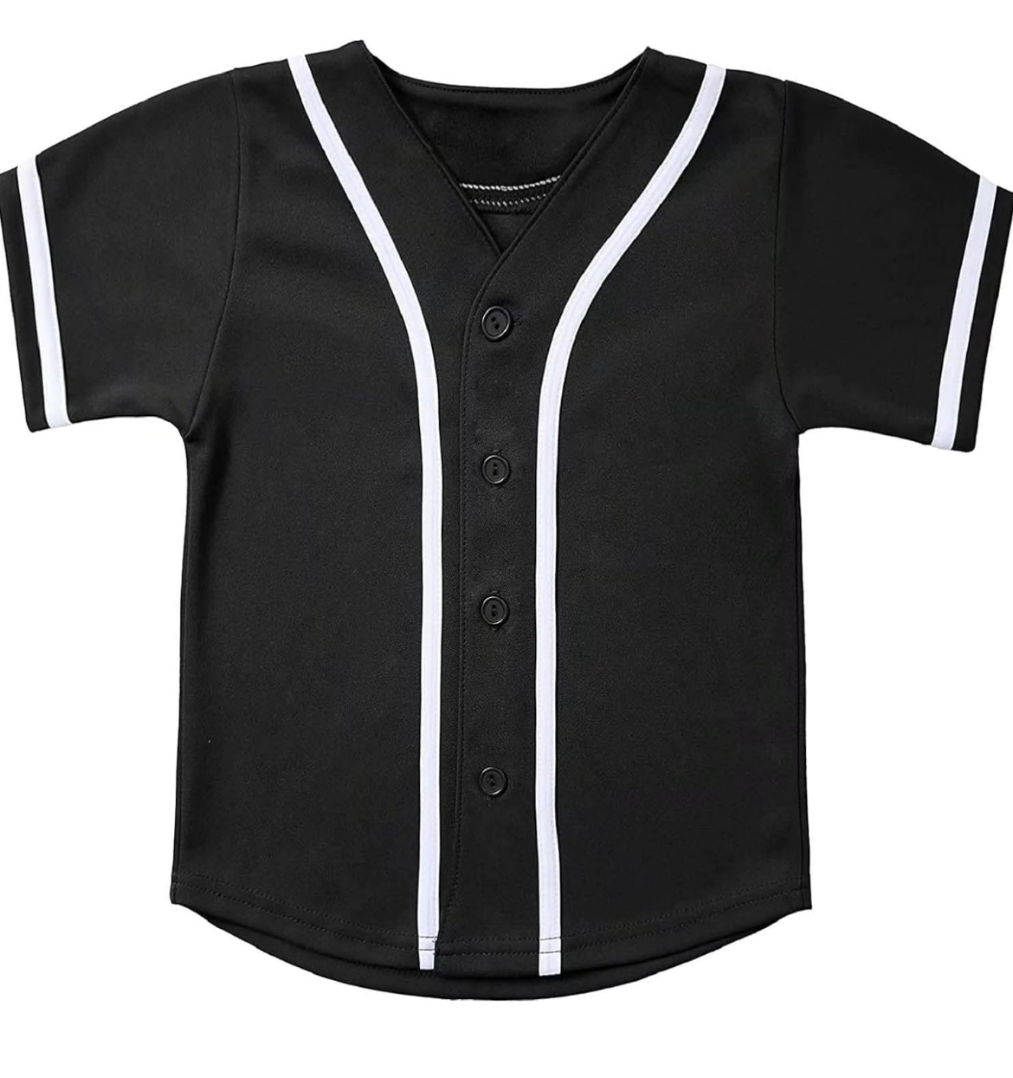
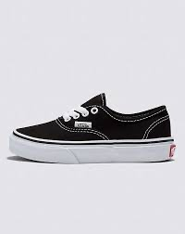
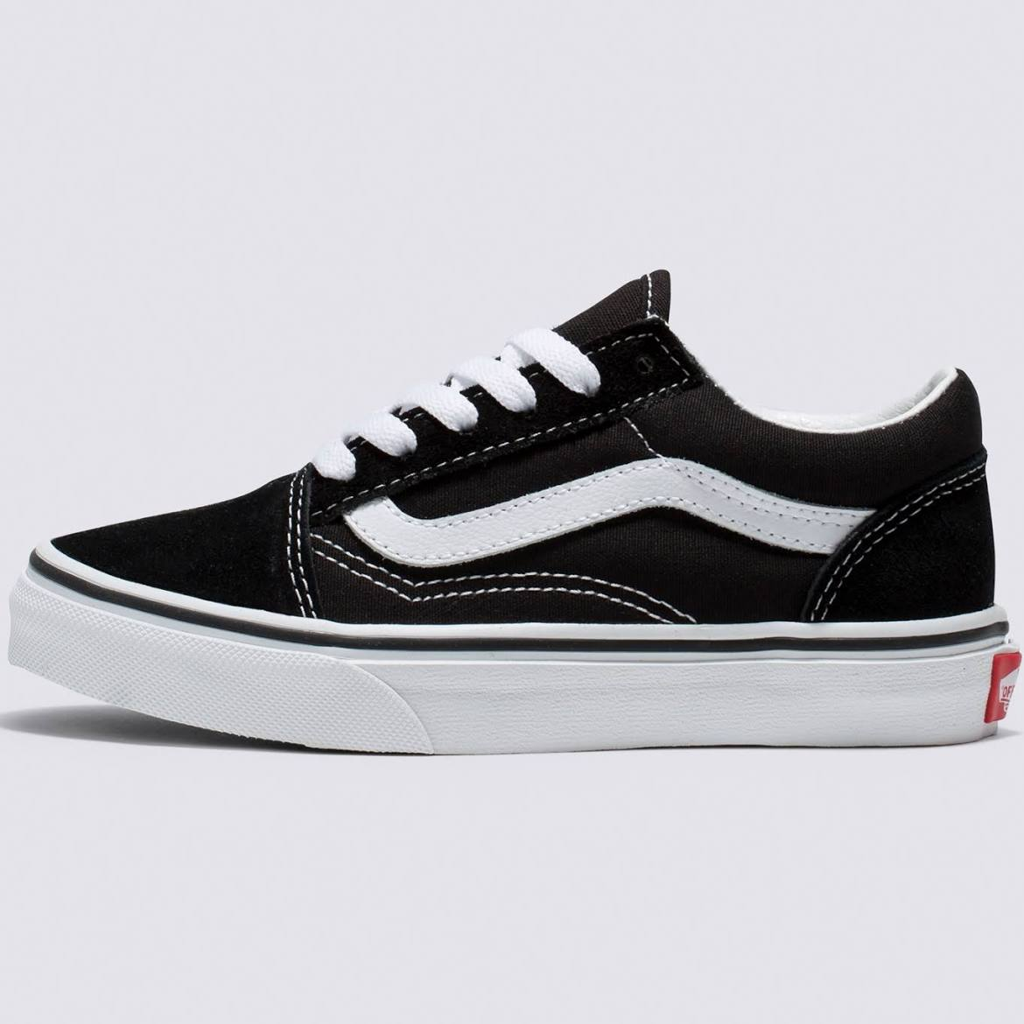
https://a.co/d/1TgDeJc - click on link to purchase baseball jersey
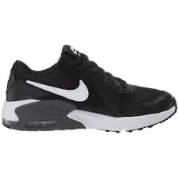

MISS KRISTA CLASSES
Class: Contemporary 5
Piece Title: Beautiful Mess
Look Description: Black cami leo and this skirt in assigned color: Skirt
Olivia- blue1, Lily- deep purple1, Naomi-lake green, Kylee-pink1, Adelae-purple1, Kendall-sage1, Alli-forest green, Eva-navy blue1, Cara-burgandy, Katie-royal blue, Somee- caramel, Kelli-pink1, Jimmy- burgundy pants from Riders and black shirt, Emma-mint green, Charlie-red1, CyMone-army green

Class: Jazz 3
Piece Title: Parade
Look Description: Black flared pants with halter top in one of the below colors. McKinley- pink, Kate-yellow, Lila-orange, Lily-light red, Morgan-pink, Ava-purple, Lexie- light red, Makayla-light red, Amy-purple, Billie-orange, Wanda-pink, Daphne- Yellow
Color Family: Sunset colors shown below and black

MISS NICOLE CLASSES
Class: Contemporary 4
Piece Title: Human
Look Description: All black vintage, gotchic - mix of black velvet and lace or sheer top and bottoms.
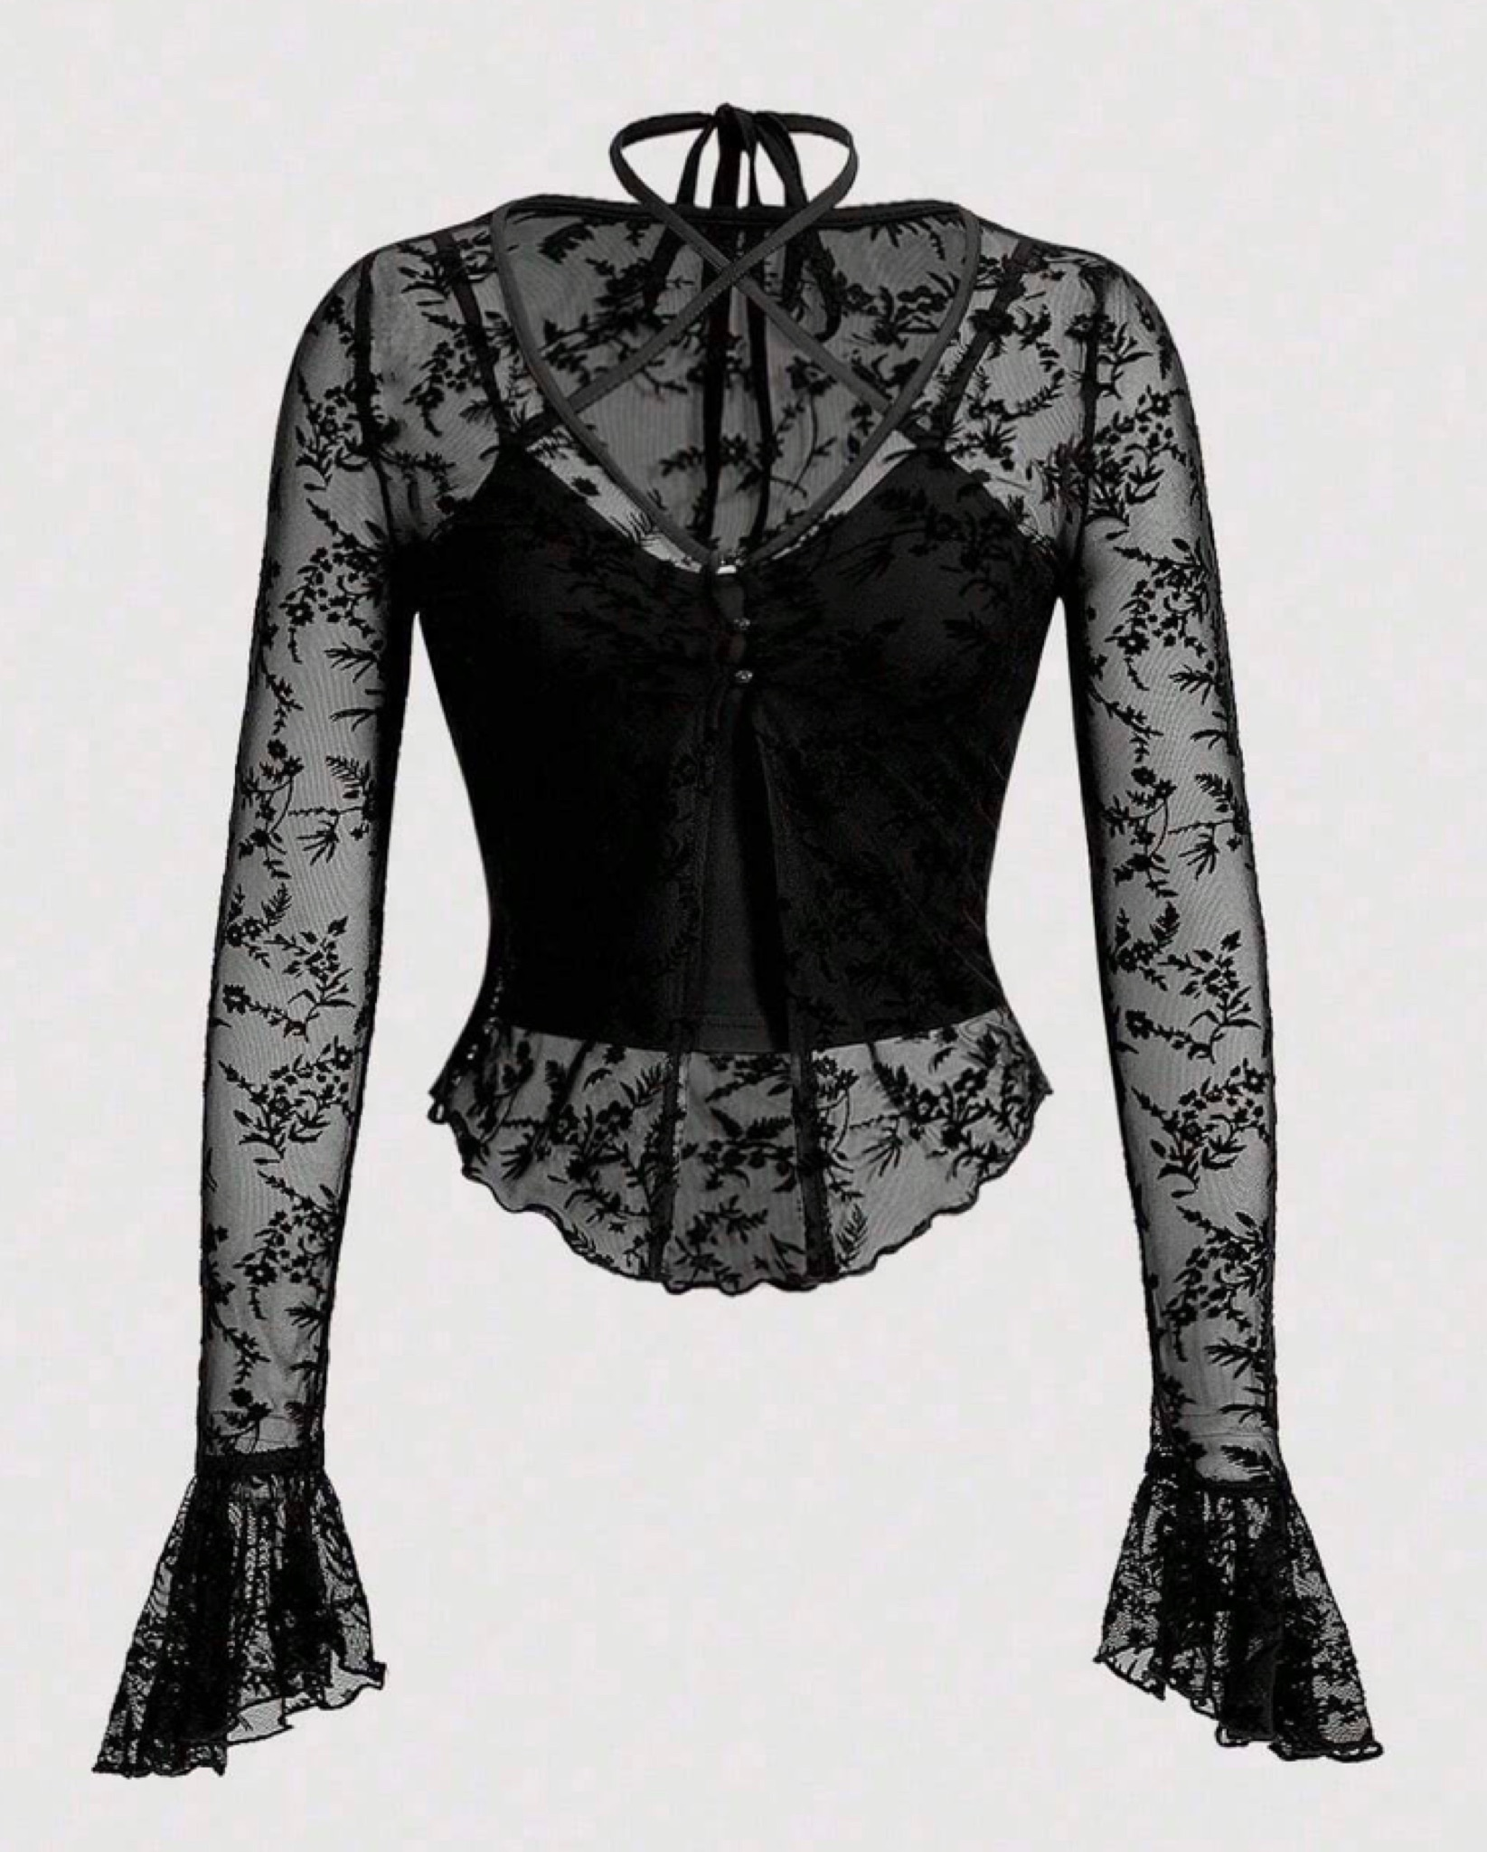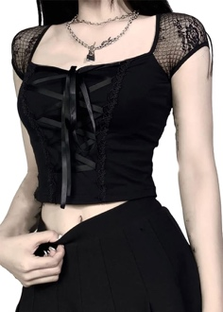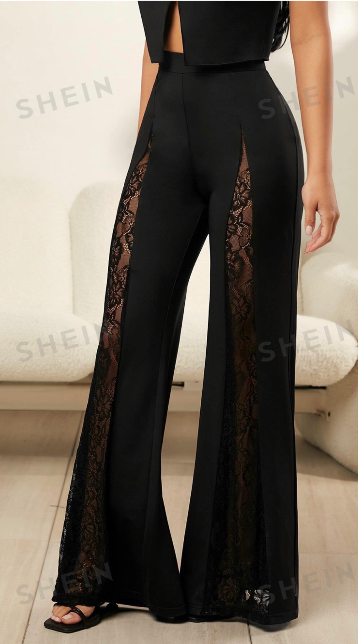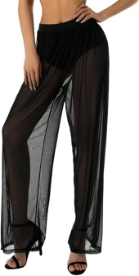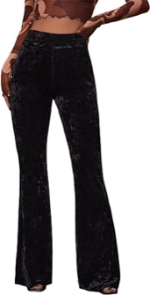

Class: Jazz 2
Piece Title: Best of My Love
Look Description: These shorts in pink
https://www.dancewearsolutions.com/bottoms/shorts/mt3228.aspx
Cute long sleeve black leotard (can include lace, sheer, embellishments, etc)
Pictures for example:
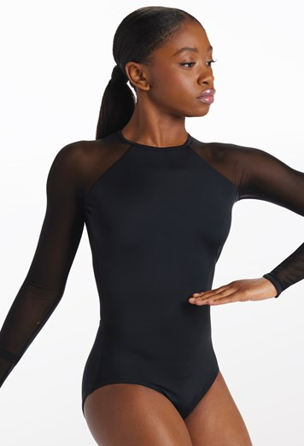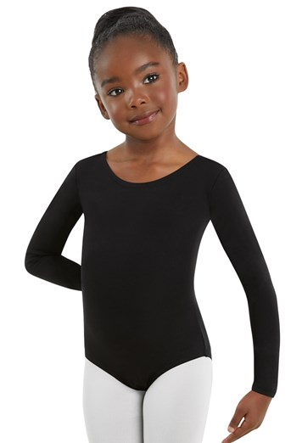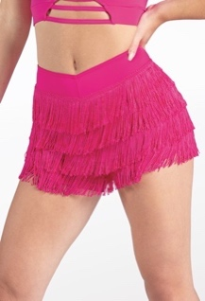

MISS AMANDA CLASSES
Class: Contemporary 3
Piece Title: Song in my Head
Look Description: Above the knee blue sundress. Any sleeve type, try for solid color
Color Family: Blue, any shade but try to stay away from teal and turquoise
Pictures for example:
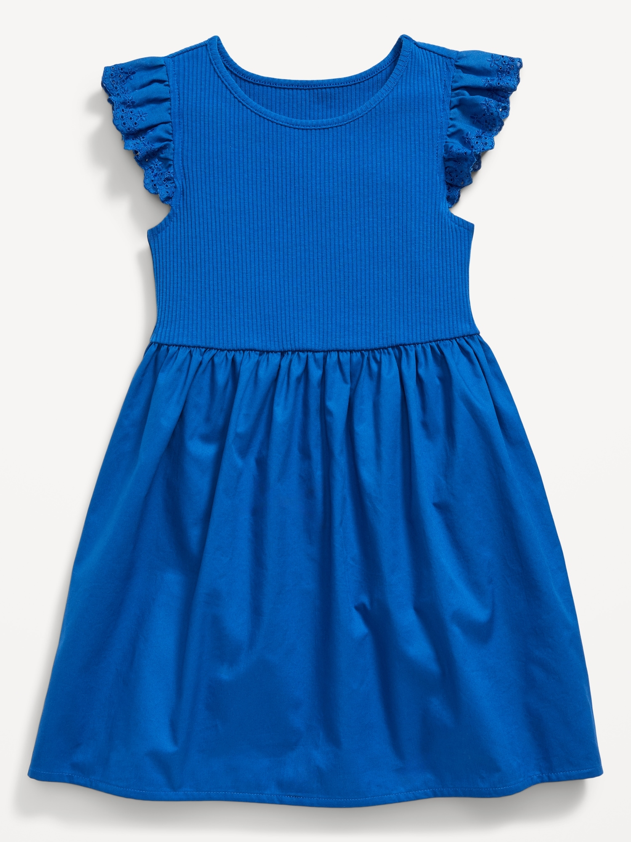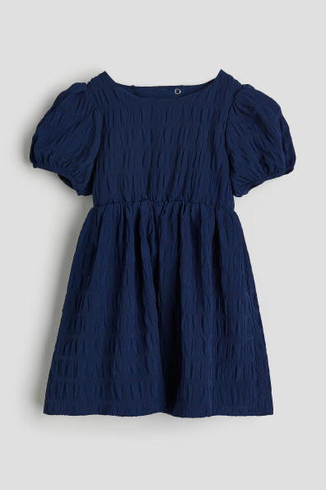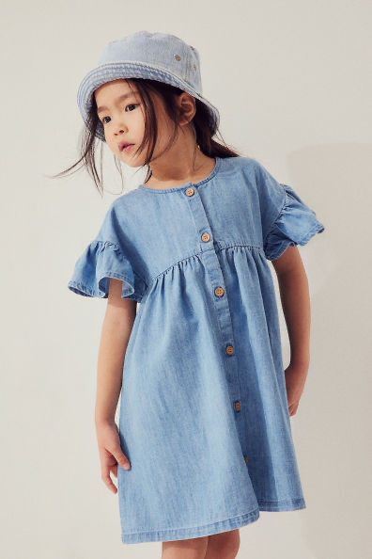

Class: Contemporary 6
Piece Title: I Want to Break Free
Look Description: Business casual attire, think slacks, button up shirt, vest, blouse
Color Family: Neutral colors (gray, navy, beige, white, black, brown)

Class: Jazz 5
Piece Title: Hold on Me
Look Description: Black leggings (plain), and red crop top, any sleeve type. For the top try and find something with sparkles, rhinestones, or sequins. Gold hoop earrings (the ones we use for Company)
Color Family: Red, any shade but try to stay away from maroon and burgundy
Pictures for example:
